The City School
North Nazimabad Boys Campus
2nd Monthly Test (1st Term)
Geography (Paper A)
Class 6
Name: _____________________ Date: _______________ Section: ______ Max. Marks: 25
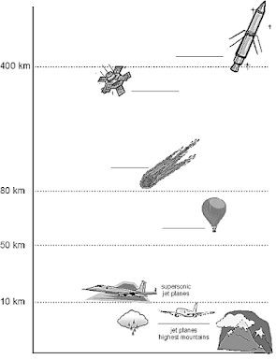
Q1a -i) Label the layers of atmosphere in the diagram below: /4

Q1a -ii) Differentiate between weather and climate. /2

_______________________________________________________________________________________
_______________________________________________________________________________________
_______________________________________________________________________________________
_______________________________________________________________________________________

Q1b) In what way solar radiations affect atmosphere.
Support your answer by describing the role of stratosphere in atmosphere. Why is this layer important in atmosphere? /3

_______________________________________________________________________________________
_______________________________________________________________________________________
_______________________________________________________________________________________
_______________________________________________________________________________________
_______________________________________________________________________________________
_______________________________________________________________________________________

Q1c) What is the greenhouse effect? How does it keep the atmosphere warm during the night? /3
_______________________________________________________________________________________
_______________________________________________________________________________________
_______________________________________________________________________________________
_______________________________________________________________________________________
_______________________________________________________________________________________
_______________________________________________________________________________________
Q2) Look at the diagrams below and answer the following:

Q2a -i) Explain the formation of the rift valley. /2
_______________________________________________________________________________________
_______________________________________________________________________________________
Q2a -ii) Write any 4 names of the landforms which are formed by the Earth Movement and Volcanic
Activity. /2
_______________________________________________________________________________________
_______________________________________________________________________________________
_______________________________________________________________________________________
_______________________________________________________________________________________

Q2b) Weathering takes place in 3 ways.
Give a short description of any two types of weathering. /2

_______________________________________________________________________________________
_______________________________________________________________________________________
_______________________________________________________________________________________
_______________________________________________________________________________________
Q2c -i) The Earth’s crust is made of rocks. They are made in three ways.
Explain the formation of sedimentary rocks with one example. /2

_______________________________________________________________________________________
_______________________________________________________________________________________
_______________________________________________________________________________________
_______________________________________________________________________________________
Q2c -ii) Earth’s crust has different types of tectonic plates. Name any four continental plates. /2
_______________________________________________________________________________________
_______________________________________________________________________________________
_______________________________________________________________________________________
_______________________________________________________________________________________
_______________________________________________________________________________________
_______________________________________________________________________________________
Q2d) Earth has different layers in it.
Into how many layers is Earth divided? Name them. /1

_______________________________________________________________________________________
Explain any two layers of earth in detail. /2
_______________________________________________________________________________________
_______________________________________________________________________________________
_______________________________________________________________________________________
_______________________________________________________________________________________

