pThe City School
North Nazimabad Boys Campus
2nd Monthly Test (1st Term)
History (Paper A)
Class 6
Name: _____________________ Date: _______________ Section: ______ Max. Marks: 25
Section A
Q1) Fill in the blanks from the choices given in the box below: /5
Harappan environment Indo-Europeans Indian
urban Arya birth race nomadic grazing

The highly organized, ___________ people of the Indus Valley or ___________ Civilization could not survive the changes in their ______________ and were taken over by the ___________, pastoral people who came from the North-west in search of _________ lands for their cattle. They settled in the ________ subcontinent between 1500-1000 BCE. These people called themselves ___________, a term which has to do with the language they spoke as ___________. The secondary meaning of Arya is noble of ____________ and __________.
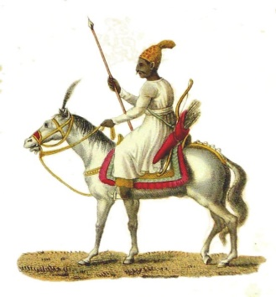
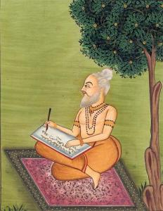
Q2) Write a detailed note about the following pictures. /5

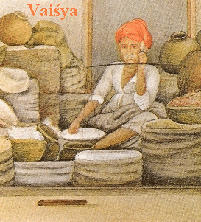
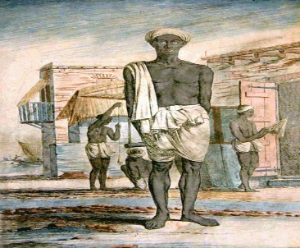

____________________________________________________________________________________________________________________________________________________________________________________________________________________________________________________________________________________________________________________________________________________________

Q3) Who am I? /5
- Defeated the Dasas and settled in the land of the five rivers. _________________
- The god of thunder. _________________
- The founder of Buddhism. _________________
- Born in 550 BCE in Patna. _________________
- Founded the Mauryan dynasty in c.320-21 BCE. _________________
SECTION B

Q1) How did Ashoka become a legendary king? /4
__________________________________________________________________________________________________________________________________________________________________________________________________________________________________________________________________________________________________________________________________________________________________________________________________________________________________________________________________________________________________________________________________________
Q2) Discuss the main teachings of Jainism and Buddhism. /6
__________________________________________________________________________________________________________________________________________________________________________________________________________________________________________________________________________________________________________________________________________________________________________________________________________________________________________________________________________________________________________________________________________
______________________________________________________________________________________________________________________________________________________________________________

