The City School
North Nazimabad Boys Campus
2nd Monthly Test (1st Term)
Geography (Paper A)
Class 7
Name: _____________________ Date: _______________ Section: ______ Max. Marks: 25
Q1) Answer the following questions. /15
a -i) Identify the type of breezes. /1
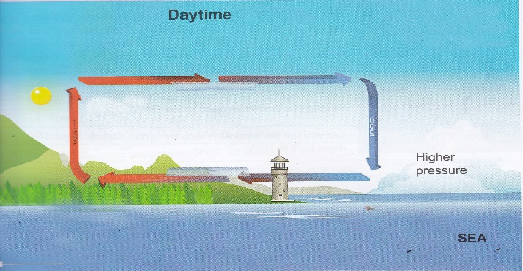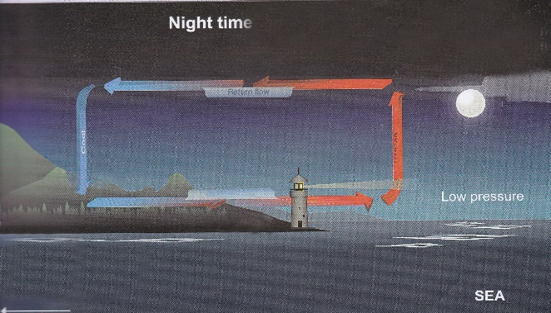
_____________________________________ _________________________________

a -ii) Why are the breezes you have named in a(i) formed? /2

_______________________________________________________________________________________
_______________________________________________________________________________________
a - iii) Differentiate between the types of breezes mentioned in a(i) /3 _______________________________________________________________________________________
_______________________________________________________________________________________
_______________________________________________________________________________________
______________________________________________________________________________________________________________________________________________________________________________
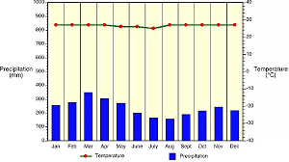
b -i) Study the graph below and answer the questions that follow.

- Which type of climate is shown in the graph. /1
____________________________________________________________________________________
- What are the reasons for the climate named in A? /3

________________________________________________________________________________________________________________________________________________________________________________________________________________________________________________________________________________________________________________________________________________
- Write characteristics of the climate shown in graph. /5

________________________________________________________________________________________________________________________________________________________________________________________________________________________________________________________________________________________________________________________________________________
Q2) Answer the following questions related to the different instruments used at weather
stations to record weather. /10
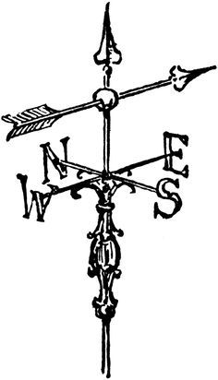
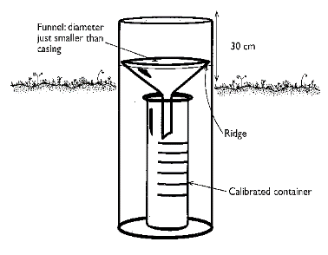
(a) /2
INSTRUMENT__________________________________________
USE__________________________________________________
_____________________________________________________
_____________________________________________________

INSTRUMENT _________________________________________
USE _________________________________________________
_____________________________________________________
_____________________________________________________

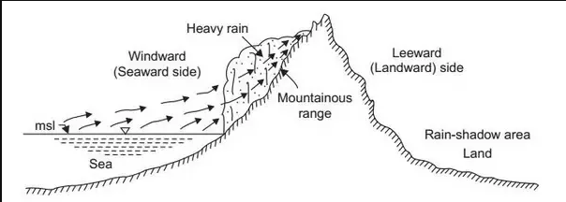
b -i) Name the type of rainfall under the figure and answer the questions related to it.

________________________________ /1

b -ii) Explain the formation of rain shown in b(i) /4
____________________________________________________________________________________________________________________________________________________________________________________________________________________________________________________________________________________________________________________________________________________________
_______________________________________________________________________________________
c. Describe the formation of cyclone. /3
____________________________________________________________________________________________________________________________________________________________________________________________________________________________________________________________________________________________________________________________________________________________
_______________________________________________________________________________________

