````````````````````````````

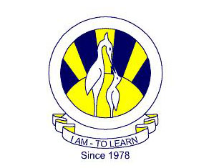
The City School
North Nazimabad Boys Campus
1st Monthly Test Term 2(2017)

S. No. | Days | Date | Class 7 | Class 8
1 | Wednesday | 1st Feb’ 17 | Urdu | Urdu
2 | Thursday | 2nd Feb’ 17 | Geography | Geography
3 | Friday | 3rd Feb’ 17 | English | English
4 | Monday | 6th Feb’ 17 | History | History
5 | Tuesday | 7th Feb’ 17 | Science | Science
6 | Wednesday | 8th Feb’ 17 | ICT | ICT
7 | Thursday | 9th Feb’ 17 | Mathematics | Mathematics
8 | Friday | 10th Feb’ 17 | Islamiyat | Islamiyat

Result Date: 1st Monthly Test Term 2(2017), 23rd Feb’ 2017
==================================================================

The City School
North Nazimabad Boys Campus
1st Monthly Test Term 2(2017)

S. No. | Days | Date | Class 7 | Class 8
1 | Wednesday | 1st Feb’ 17 | Urdu | Urdu
2 | Thursday | 2nd Feb’ 17 | Geography | Geography
3 | Friday | 3rd Feb’ 17 | English | English
4 | Monday | 6th Feb’ 17 | History | History
5 | Tuesday | 7th Feb’ 17 | Science | Science
6 | Wednesday | 8th Feb’ 17 | ICT | ICT
7 | Thursday | 9th Feb’ 17 | Mathematics | Mathematics
8 | Friday | 10th Feb’ 17 | Islamiyat | Islamiyat

Result Date: 1st Monthly Test Term 2(2017), 23rd Feb’ 2017
==================================================================

