The City School
North Nazimabad Boys Campus
Chapter – 5 (Robotics)
Class 8
- GPIO = General Purpose Input Output
Q.2 What is Raspberry Pi 3?
Ans. The Raspberry Pi is a single board credit card sized microcomputer developed in UK by Raspberry Pi Foundation in 2012. Raspberry Pi is an ARM Architecture processor based board, a CPU of 1.2 giga hertz, 1 GB RAM and supports SD cards as external hard disk.
Q.3 What is the purpose of Caster wheel?
Ans. It provides easy rolling movement of the robotic car while turning right or left and moving back and forth.
Q.4 What is the purpose of DC Motors?
Ans. Mounted along with wheels, provides back and forth movement of robotic car.
Q.5 What is the function of Servo Motor?
Ans. Moves with a great precision and provides a locomotion to a SONAR sensor as it is mounted on it.
Q.6 What is Sonar Sensor?
Ans. Detect distance and avoid obstacles.

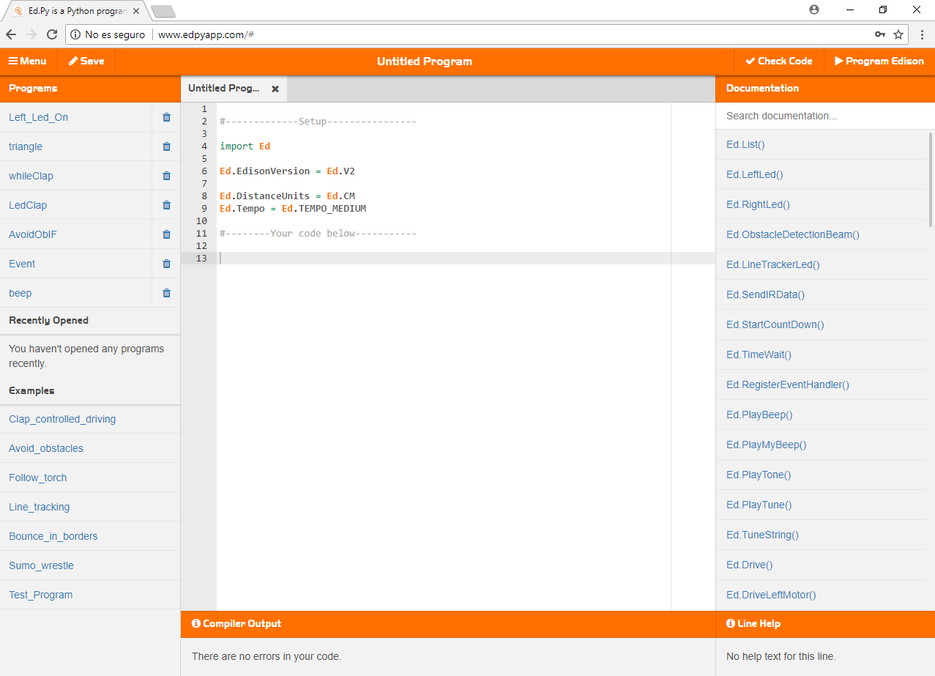
………………….…
..
…………………
…………………………
….

………………….…
..
…………………….
….
…………………….
…
…………………

Q.7 Fill in the blanks:
1. The Edison robot can also be programmed with a programming language called EdPy.
2. EdPy is a text-based programming language based on Python.
3. EdPy application can be used online without any installation on your computer.
4. Drive code = Ed.Drive (direction, speed, distance)
5. For robot turning, use a variable = degreesToTurn
6. We use FOR loop with range ( ) function.
7. The syntax of while loop in Python is while condition 1:
Statement ( )
8. An event handler is use to set up the event in your code.
9. The basic difference between the “For Loop” and “While loop” statements is that we use the first when we already know how many times the commands will be executed and the second when we don’t know the number of repetitions.
10. An infrared sensor which can detect obstacles that are in front of the Edison robot.
11. Edison robot also has a sound sensor that allows it to respond to sounds.
12. For more complicated actions and decisions, you can use statements in your coding such as “if”, “elif” and “else”. These provide the robot with three deferent paths that the robot can take when it detects an obstacle, based on where the obstacle is.

