The City School
PAF Chapter, Prep Section
Reinforcement Worksheet – Topic : “Scratch”

SECTION-A  Q1: Fill in the blanks.  - Scratch is a .  - Scratch projects are made up of objects called ________________.  - You can change how a sprite looks by giving it a different .  - The _________is where you see your stories, games, and animations come to life.  - To program a sprite, we drag out blocks to the .  - To see and edit the sprite’s costume, click the tab.  - You can use to create or edit costumes and back grounds.  - Click the ___________ button to remove all content from the Canvas.  - The ______ Flag provides a convenient way to start many scripts at the same time.  - ___________ uploads your project to the Scratch website. | SECTION-B  Q1: Define the Following terms of Scratch:  - Green Flag  - Rotation Style  - Stage  - Costumes  - Sprite
SECTION-C

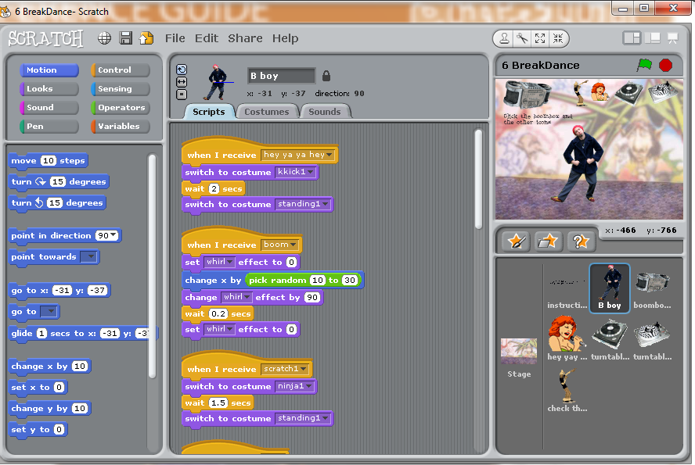

The City School / PAF Chapter/ Scratch Reinforcement Worksheet/ 2017 / ICT/ Class 6

SECTION-D
Q1: Fill in the blanks.
- Scratch projects are made up of objects called ________________.
- The _________is where you see your stories, games, and animations come to life.
- To program a sprite, we drag out blocks to the .
- Scratch is a language.
- The ______ Flag provides a convenient way to start many scripts at the same time.
- Scratch is a language.
- You can change how a sprite looks by giving it a different .
- The objects or characters in scratch are called ______________.
- The ______ Flag provides a convenient way to start many scripts at the same time.

Q2. Match column A with B and write the answers in column C.

A |  | B |  | C
1 | move | a | This block creates a pause whenever needed
2 | forever | b | Scripts that wear this block will activate once the Green Flag has been clicked.
3 | wait | c | Scripts held inside this block will be repeated forever.
4 | When green  Flag Clicked | d | This block is used to move the sprite from one place to another place.

Q.3. Write the Name and its description
Tool Name Description

The City School / PAF Chapter/ Scratch Reinforcement Worksheet/ 2017 / ICT/ Class 6

Q.4 (a) Define the following terms:
Costume: | Stage:
Script: | Sprite
Block Palettes: | Green Flag:
Control in Block Palette: | Motion in Block Palette:
Q.4 (b) Write the purpose of the following scratch commands.

S.No. | Blocks/Command | Purpose
1. | Wait
2. | Move
3. | Switch to background
4. | Next background
5. | Switch to costume
6. | Next costume
7. | Forever
9. | Say
10. | Think
11. | Go to x:__ y: __
12. | When Green Flag Clicked

