Teacher Name: Zakia Amir Class: 7 Subject: Science Dater: 12th October, 2019

Q1: Differentiate between a mixture and Compound.
Mixture | Compound

Q2: Identify the separation technique for the following mixtures:

 | Mixtures | Separation technique
1 | Sugar solution
2 | Iron filling and sand
3 | Drugs from blood sample

Q3: Charles used the chromatography technique to analyze his drink. Which component did
he find in his drink x, y or z

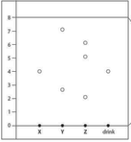

Answer ______________________

