Teacher Name: Zunayyara Class: 6 Subject: Geography Date: 6-4-19

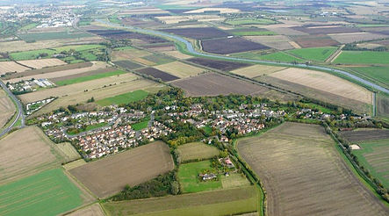

Q1.Observe the above picture and comment on the type of settlement.
What are the reasons that on a plantation estate this type of settlement is preferred?
Ans._______________________________________________________________
___________________________________________________________________
___________________________________________________________________
___________________________________________________________________
___________________________________________________________________
___________________________________________________________________
___________________________________________________________________
___________________________________________________________________
___________________________________________________________________
___________________________________________________________________
___________________________________________________________________
___________________________________________________________________
___________________________________________________________________

Q2.Discuss about the advantages, the residents (people) of planned cities are having?
Ans._________________________________________________________________________
___________________________________________________________________
___________________________________________________________________
___________________________________________________________________
___________________________________________________________________
___________________________________________________________________
___________________________________________________________________
___________________________________________________________________
___________________________________________________________________
___________________________________________________________________
___________________________________________________________________
___________________________________________________________________
___________________________________________________________________

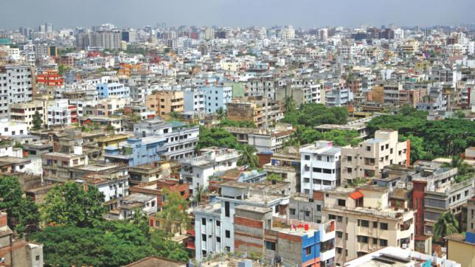

Q3. Discuss about the problems faced by the residents of unplanned residential zone.
Ans._________________________________________________________________________
___________________________________________________________________
___________________________________________________________________
___________________________________________________________________
___________________________________________________________________
___________________________________________________________________
___________________________________________________________________
___________________________________________________________________
___________________________________________________________________
___________________________________________________________________
___________________________________________________________________
___________________________________________________________________
___________________________________________________________________

