Q1a. Observe the given map and attempt the questions.
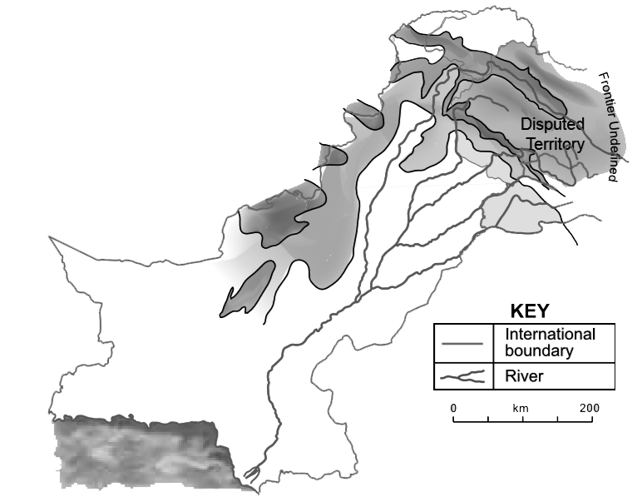
D
C
B
A
- Name the Plateaus A____________________ & B _________________
- Name the mountain ranges C _______________ & D ________________
b.
A B
i. Identify the landform A _____________________ & B ___________________
ii. How the landform A different from the landform B?
c. Describe the phenomenon of “alternate freezing and thawing of water in cracks”?
Q2. Observe the given picture and answer the questions.
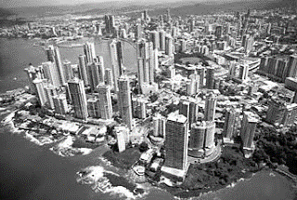
Identify the type of environment seen in the given picture.
- Describe the given picture.
- “Every change brings negative and positive consequences.” To what extent do you agree with the given statement? Explain with the reference of the picture given.
Q2. Colourful lights are visible on the sky at night on the North and South poles. Explain the phenomenon of aurora to show the formation of these lights.

Q3. Discuss what happens when a plate move towards another plate.
Q4. There are many landforms formed by volcanic activity. Explain the formation of volcano eruption.

Q5. Describe the layers of atmosphere with their temperatures.
Q6. Describe the occurrence of earthquake. How does it occur due to the plate movement.
Q7. Weathering is a process in which rocks break down. Discuss the three ways by which rocks are broken down into small fragments.
Q8. Crustal rocks are of different types. Write down the formation of these rocks and give examples of each type.
Q9. Name the Tectonic plates. Categorize them into continental and oceanic plates.
Q10. Draw and describe the structure of earth in detail.
Define the following:
- Latitude
- Longitude
- Terrace
- Linear scale
- Tropic of Cancer
- Tropic of Capricorn
- Latex
- Manufacturing industry
- Service industry

