Teacher Name: Zunayyara Class: 6 Subject: Geography Date: 15 September, 2019
Q1) Name different types of graphs and identify the graphs given below.

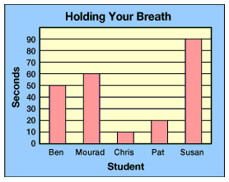
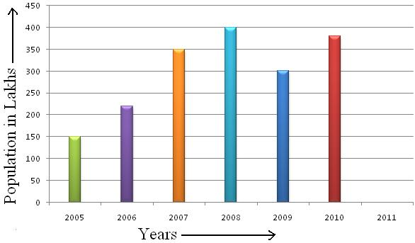

1 _____________________ 2 ____________________

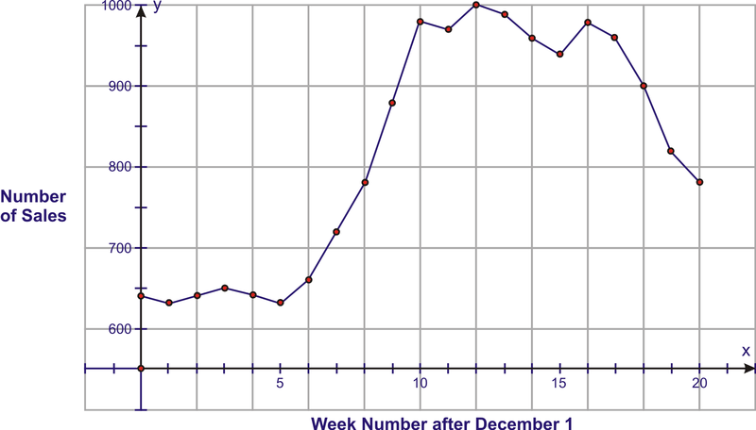
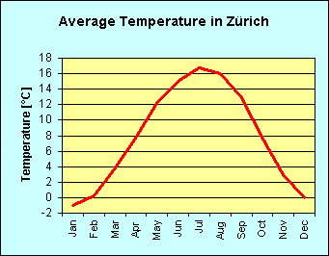

3_____________________ 4___________________

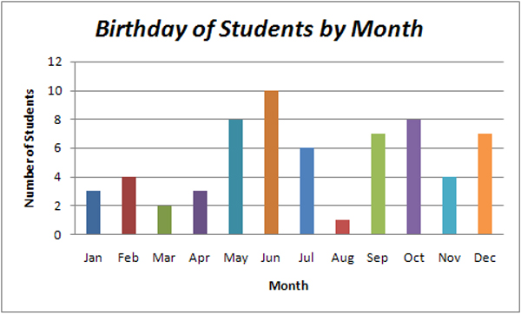

Q2. Observe the graph and answer the following questions:
- In which month of the year, most number of students have their birthdays?
Ans. ___________________
- How many students have their birthdays in February and November?

Ans. ___________________
- In which month only one student has the birthday?

Ans. ___________________
- In which months 8 students have their birthdays?
Ans. ___________________
- How many students have their birthdays in the months of January, February, March and April altogether?
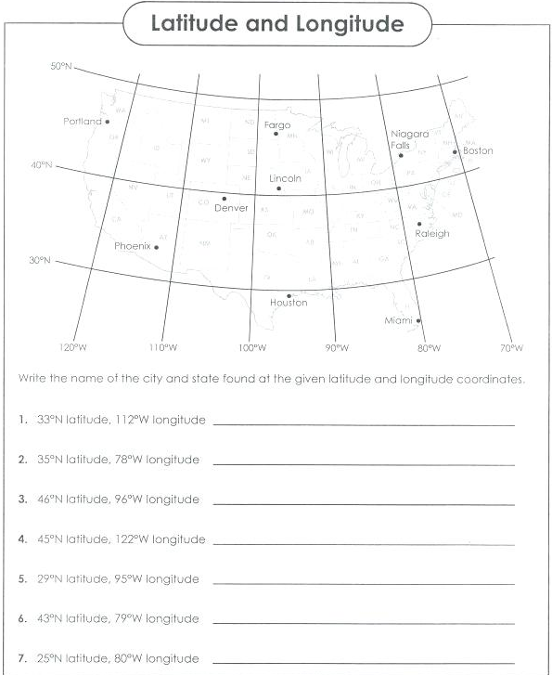
Ans. ___________________

