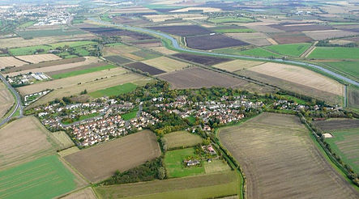
Teacher Name: Zunayyara Furqan Class: 6 Subject: Geography Date: 16th November,2019

Q1.Observe the above picture and comment on the type of settlement.
What are the reasons that on a plantation estate this type of settlement is preferred?
Ans.___________________________________________________________________________________________________________________________________________________________________________________ __________________________________________________________________________________________________________________________________________________________________________________________________________________________________________________________________________________________________________________________________________________________________________________________________________________________________________________________________________________________________________________________________________________________________
Q2.With the help of the source given below, answer the questions that follows;
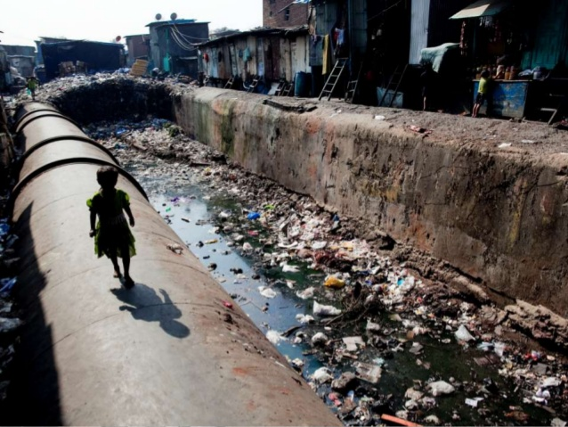

- Identify the type of settlement.
- Discuss about the problems faced by the dwellers of this settlement.
- If you be given the chance, how you will provide relief to the dwellers of this area.
- Why people in this settlement are easily prone to diseases.

________________________________________________________________________________________
________________________________________________________________________________________
________________________________________________________________________________________
________________________________________________________________________________________
________________________________________________________________________________________
________________________________________________________________________________________
________________________________________________________________________________________
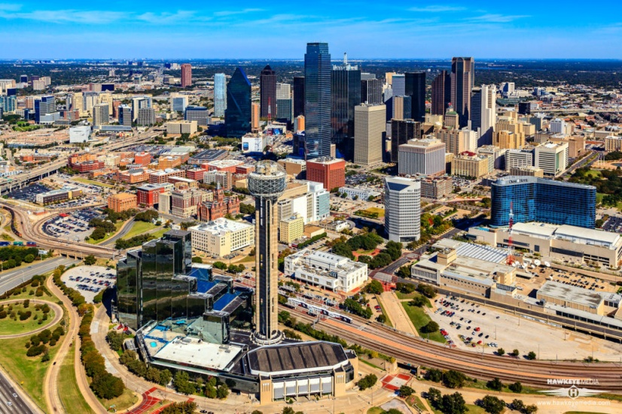

Q3.Discuss about the advantages, the residents (people) of planned cities are having?
Ans. ________________________________________________________________________________________
________________________________________________________________________________________
________________________________________________________________________________________
________________________________________________________________________________________
________________________________________________________________________________________
________________________________________________________________________________________
________________________________________________________________________________________
________________________________________________________________________________________
________________________________________________________________________________________
________________________________________________________________________________________

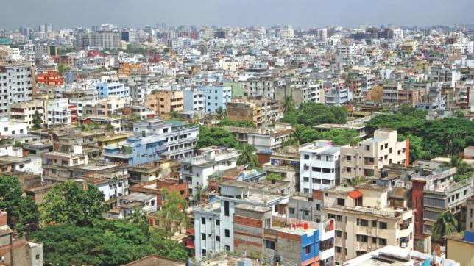
Q4.Discuss about the problems faced by the residents of unplanned residential zone.
Ans.___________________________________________________________________________________________________________________________________________________________________________________ ________________________________________________________________________________________________________________________________________________________________________________________________________________________________________________________________________________________________________________________________________________________________________________________________________________________________________________________________________________________________________________________________________________________________________________________________________________________________________________________________________________________________________________________________________________________________________________________________________________________________________________________________________________________________________________________________________________________________________________________________________________________________________________________________________________________________________________________________________________________________________________________________________________________________________________________________________________________________________________________________________________________________________________________________________________________________________________________________________________________________________________

