Teacher Name: Aqsa Kamran Class: 7 Subject: Geography Date: 2nd November, 2019

Q.1a) Identify the landform shown in the picture below

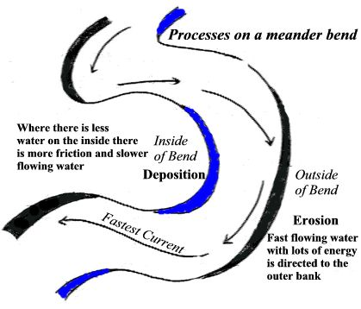

___________________________________________________________________________________________

b) Name the features responsible for this landform.

___________________________________________________________________________________________

c) Describe the formation of the landform shown in picture
____________________________________________________________________________________________________________________________________________________________________________________________________________________________________________________________________________________________________________________________________________________________________________________________________________________________________________________________________________________________________________________________________________________________________________________________________________________________________________________________________

