The City School
Class 7 worksheet 1 Summer Vacations Ms. Beenish

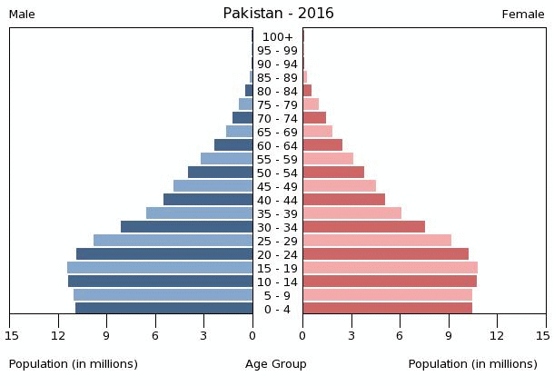
Q: Discuss the main features of the population pyramid.
___________________________________________________________________________________________________________________________________________________________________________________________________________________________________________________________________________________________________________________________________________________________________________________________________________________________________________________________________________________________________________________________________________________________________________________________________________________________________________________________________________________________________

Q: What are the population issues of MEDC?
__________________________________________________________________________________________________________________________________________________________________________________________________________________________________________________________________________________________________________________________________________________________________________________________________________________________________________________________________________________________________________________________________

