The City School
NNBC
Class: 7 Subject: Math
Question Bank for grade 7
Numbers and Integers/Estimation and Approximation (numbers and decimals)
Q1. Evaluate the following.
- (-4) x 1 x (8) ÷ 2 x 4
- (-3)² – (-4 x 3) + (1 x 4²)
Q2. Place the following in descending order.
$\frac{33}{100}$, 33$\frac{1}{3}$,$\frac{3}{25}$,$\frac{3}{50}$,$\frac{67}{200}$
Q3. Estimate the value of
- $\frac{64.11}{1.62}$
- 56.96713 -34.23067
Correct to 1 significant figure.
Q4. Express 1.499 correct to
- 2 decimal places
- 3 significant figures
Q5. Evaluate
- $\frac{2}{3}$ - $\frac{3}{5}$
- 32.5 $÷$ 13
- 1$\frac{1}{5 }$ $÷$ 2$\frac{1}{3}$
Q6. Aishah buys some exercise books for $6.05.
- How much change will she get from $10?
- How many exercise books she buy if each book costs 55 cents?
Q7.$\frac{2}{3}$ Of a plot of land is garden.
$\frac{1}{5}$ Of the garden is lawn.
Find the fraction of the plot of land which is lawn.
Q8. It is given that$\frac{2}{3}$, $\frac{8}{d}$ and $\frac{n}{39}$ are equivalent fractions. Find the value of d and the value of n.

Q9. A group of people were standing in line. ³/₈ of the people were boys and ¹/₄ of the people were girls. How much of the group was made up of boys and girls?
How much of the group was not boys or girls?

Q 10. a) Jane and Jerry were counting the months until their birthdays. Jane said³/₄ of the year would pass before it was her birthday. Jerry said he only needed to wait ¹/₃ of the year. How much longer did Jane have to wait than Jerry?
Change your answer to ‘how many’ months.

b) Bill ran around ²/₃ of the track. Josh ran around ⁵/₆ of the track. How much farther did Josh run than Bill?
c) A box of paper clips fell on the floor. Betty picked up ²/₅ of the paper clips and Joanne picked up ³/₁₀. How many of the paper clips did they pick up altogether?
How many were still on the floor?
d) How many sweets would be in a bag of 28 sweets after ¼ of them had been eaten?

- A paint mixture is made up of $\frac{3}{20}$ red paint and $\frac{9}{20}$ blue paint and the rest is white.
- What fraction of the mixture is white paint?
- The paint is sold in 5-litre containers. How many litres of red paint are needed for each container?
- How many litres of blue paint are needed for each container?

- Jason has 5 feet of rope. If Jason cuts the rope into ¼ foot pieces, how may pieces will he have?
- If $\frac{1}{3}$ of a sum of money is $21, what is the sum of money?
- Rachel spends 1/4 of her pocket money on chocolates, 1/8 on pizza. At the end she had $ 40 left. How much did she have at the beginning?
Q11.
a) Find the 40th term in the sequence:
5; 2; -1; -4…

b) The seating of a sports stadium is arranged so that the first row has 15 seats, the second row has 19 seats; the third row has 23 seats and so on. Calculate how many seats are in the twenty-fifth row.
c) Which term in the sequence
1; -2; -5; …. is equal to -32?
d) In each case the general term is given write down the first three terms of the sequence:
4.1 4.2
e) Write down the next three terms of the sequence:
6; 4; 0; -6; …
e) Find the formula for the general term of the sequence:
6; 10; 14; 18; …
Q12.
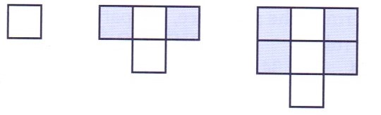

- Draw the next two diagrams in the sequence.
- Copy and complete this table.
Number of white tiles | 1 | 2 | 3 | 4 | 5
Number of blue tiles

- Describe the pattern linking the number of white tiles and the number of blue tiles.
- Use your rule in part c) to predict the number of blue tiles in a pattern with 100 white tiles.
Q13.
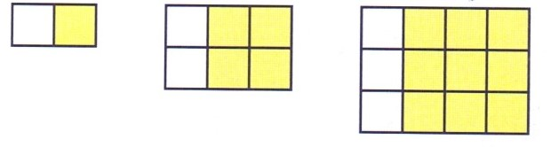
- Draw the next two diagrams in the sequence.
- Copy and complete this table.

Number of white tiles | 1 | 2 | 3 | 4 | 5
Number of yellow tiles

- Describe the pattern linking the number of white tiles and the number of yellow tiles.
- Use your rule in part c) to predict the number of yellow tiles in pattern with 100 white tiles.
Q14. For each of the sequences
- Find the nth term of yellow tiles
- Write down the next two terms of the sequence
- Calculate the tenth term
- 2 4 6 8 10
- 144 132 120 108
- 9 18 27 36 45

Q15. How many milligrams are there in 1 tonne?
a) Convert the following to the units stated in the brackets.
    - 0.008 m (mm) ___________________________
    - 6.8 cm (mm) ___________________________
    - 0.05 km (m) ___________________________
    - 175600 m (km) ___________________________
    - 0.002 tonne (kg) ___________________________
    - 6.6 litres (ml) ___________________________
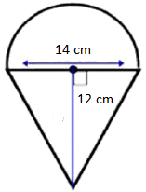
Q16. a) Work out the area of the shape given below. Give your answers correct to two decimal places. (Take π =).

  - Find the area of the given shape. (Take π =).

6cm

  - In the given rectangle the circular portions are quadrants. Calculate the area of the shaded region. (Take π =).
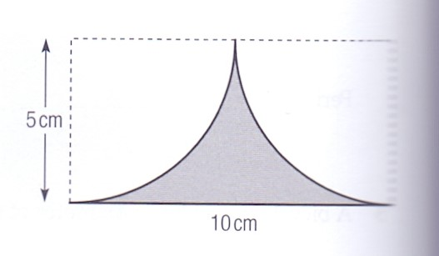

  - Write in the missing numbers to make each of these calculations correct.
    - $\left(-7\right)×_____________=(-21)$
    - $\left(+6\right)×_____________=(-48)$
    - $_____________ ×(-5)=(+15)$
  - Calculate the value of a – b when a = ½ and b = -½
  - Write an expression for the area of a rectangle 9 units long and (2x – 7) units wide
  - Write an expression for the perimeter of the rectangle in f).
  - A square has side length (p-1) units. Write an expression for its perimeter.
  - y= 4uv-3v
Find the value of y when u= -3 and v=2

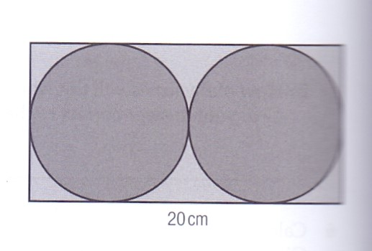
  - This diagram shows two circular discs inside a rectangular frame. The discs just fit inside the frame. Calculate the area of the rectangle not covered by the discs.

  - If $∛x$ =2, then x=_________
  - Simplify
$\frac{3y-2}{6}$ - $\frac{y+9}{9}$
  - Solve:
- 8.3 – 3x = 2.6 ii) $\frac{15}{2x - 1}$ = 5

  - Complete the table given below:
S.No. | Column 1 | Column 2
1 |  | A= $\frac{x + y + z}{3}$
2 | The total cost $T of d chairs at $p each and c tables at $Q each

Q17. Three beakers contain 0.5 liters, 0.42 litres and 220 ml of solution.
- What is the total volume of the solution in millilitres?
- How many litres of water is needed to make the volume of solution up to 1.25 litres?
Q18.Four boys share a certain amount of money. The first boy receives $\frac{1}{6 }$ of it, the second $\frac{1}{4}$ and the third$\frac{1}{2}$. If the boy received $ 5, how much was the sum of money shared?

