Teacher Name: Class: Subject: Date:5th June 2018.
Seema Adil 7 Science

Topic: Forces and their Effects

Name:_________________________ Sec: _______ Date: ________________

Q. Ex A: Find the density of a substance.
Is the substance regular or irregular: ____________________
Step 1  Measure the mass | 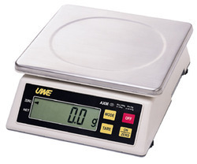  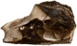  50 g | Mass = ________ g
Step 2  Find the volume of an irregular substance | 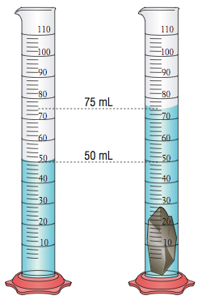 | 1 ml = 1 cm³  Volume: ________ cm³
Step 3  Calculate the density | Formula: | Density = ________ g/cm³
Find the volume of a substance.
Density – 25 g/cm³  Mass - 100 g | Formula: | Volume:  ________ cm³
Ex C: Calculate the upthrust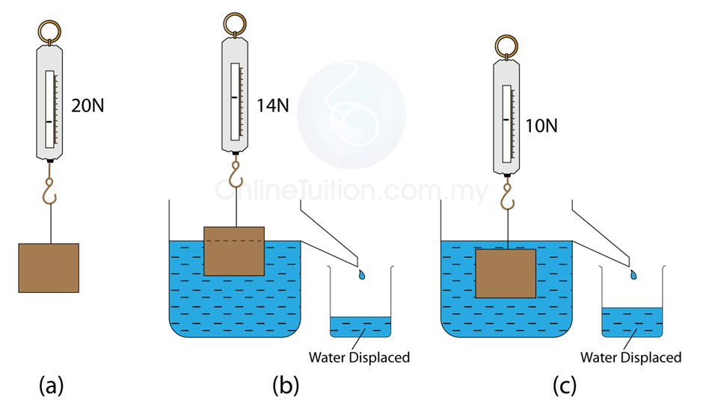

Weight of object in air - _______ N  Weight of object in water - _______ N | Upthrust = _____________N

Q.2 Define the following:
Density
____________________________________________________________________________________________________________________________________________________________________
Force
___________________________________________________________________________________________________________________________________________________________________
Up thrust
____________________________________________________________________________________________________________________________________________________________________
Gravitational Force
____________________________________________________________________________________________________________________________________________________________________
Air resistance
____________________________________________________________________________________________________________________________________________________________________
Friction
____________________________________________________________________________________________________________________________________________________________________
Q.3 What are the advantages and disadvantages of friction? HOW CAN WE REDUCE FRICTION?
__________________________________________________________________________________________________________________________________________________________________________________________________________________________________________________________________________________________________________________________________________________________________________________________________________________________
Q.4 What are the organs of human body? State the functions of each organ.
________________________________________________________________________________________________________________________________________________________________________________________________________________________________________________________________________________________________________________________________________

