Teacher Name: Ambreen Badar Class: 8 Subject: Mathematics Date:-11th February 2020
Topic: Indices

Q1: Simplify:
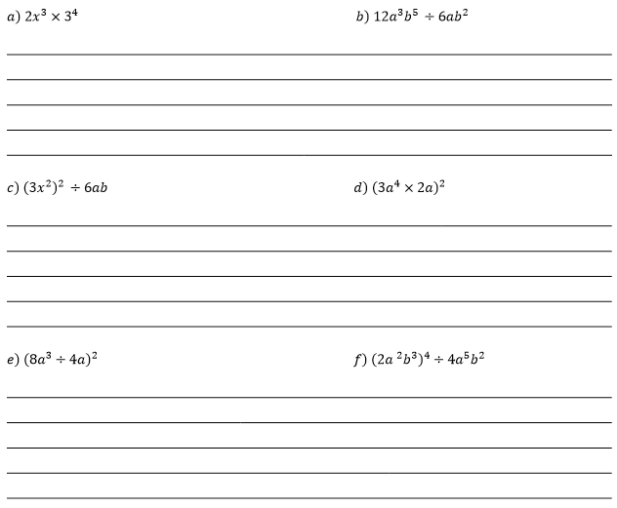
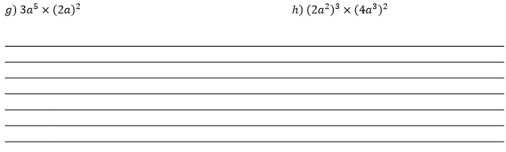

Q2: Simplify each of the following , giving your answer in positive index notation.

Q3: Simplify:
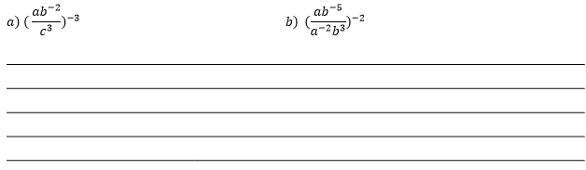
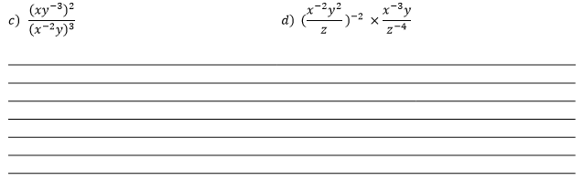
Q4: Evaluate:
