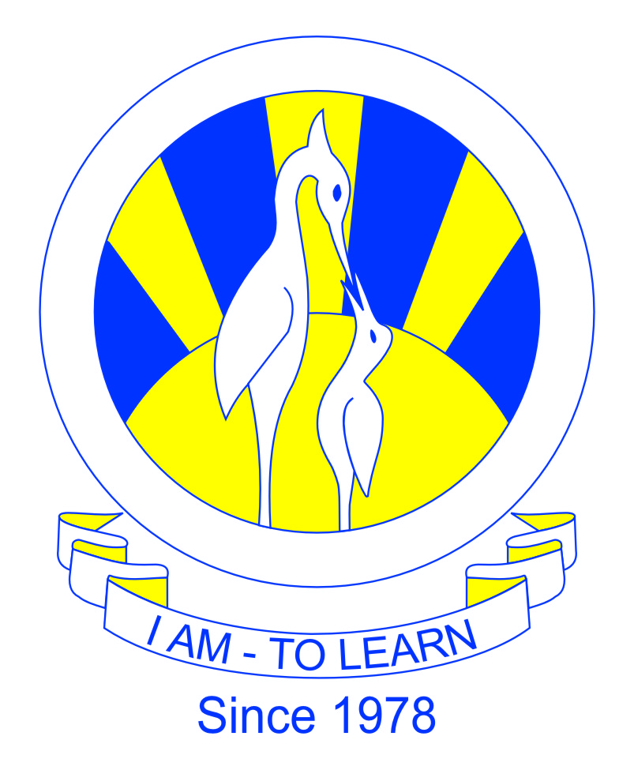
The City School
North Nazimabad Boys Campus
2nd Monthly Test (1st Term)
English (Paper B)
Class 8
Name: _____________________ Date: _______________ Section: ______ Max. Marks: 25
Q1) Read the following text and answer the questions that follow:

“Dawn take you all, and be stone to you!” said a voice that sounded like William’s. But it wasn't. For just at that moment the light came over the hill, and there was a mighty twitter in the branches. William never spoke for he stood turned to stone as he stooped; and Bert and Tom were stuck like rocks as they looked at him. And there they stand to this day, all alone, unless the birds perch on them; for trolls, as you probably know, must be underground before dawn, or they go back to the stuff of the mountains they are made of, and never move again. That is what had happened to Bert and Tom and William.

He took it and gazed long at it, and he shook his head; for if he did not altogether approve of dwarves and their love of gold, he hated dragons and their cruel wickedness, and he grieved to remember the ruin of the town of Dale and its merry bells, and the burned banks of the bright River Running. The moon was shining in a broad silver crescent. He held up the map and the white light shone through it. “What is this?” he said. “There are moon-letters here, beside the plain runes which say ‘five feet high the door and three may walk abreast.’” “What are moon-letters?” asked the hobbit full of excitement.

Suddenly a sword flashed in its own light. Bilbo saw it go right through the Great Goblin as he stood dumbfounded in the middle of his rage. He fell dead, and the goblin soldiers fled before the sword shrieking into the darkness. The sword went back into its sheath. “Follow me quick!” said a voice fierce and quiet; and before Bilbo understood what had happened he was trotting along again, as fast as he could trot, at the end of the line, down more dark passages with the yells of the goblin- hall growing fainter behind him. A pale light was leading them on. “Quicker, quicker!” said the voice. “The torches will soon be relit.”

Then he asked his second: Voiceless it cries, Wingless flutters, Toothless bites, Mouthless mutters. “Half a moment!” cried Bilbo, who was still thinking uncomfortably about eating. Fortunately he had once heard something rather like this before, and getting his wits back he thought of the answer.

A box without hinges, key, or lid, yet golden treasure inside is hid, he asked to gain time, until he could think of a really hard one. This he thought a dreadfully easy chestnut, though he had not asked it in the usual words. But it proved a nasty poser for Gollum. He hissed to himself, and still he did not answer; he whispered and spluttered.

Bilbo’s heart jumped into his mouth. He gave a terrific squirm. Buttons burst off in all directions. He was through, with a torn coat and waistcoat, leaping down the steps like a goat, while bewildered goblins were still picking up his nice brass buttons on the doorstep. Of course they soon came down after him, hooting and hallooing, and hunting among the trees. But they don’t like the sun: it makes their legs wobble and their heads giddy. They could not find Bilbo with the ring on, slipping in and out of the shadow of the trees, running quick and quiet, and keeping out of the sun; so soon they went back grumbling and cursing to guard the door. Bilbo had escaped.

i. Which sword is the author talking about in 3rd paragraph? What other names are used for it? What quality does it have? /3

_______________________________________________________________________________________________

_______________________________________________________________________________________________

ii. What are moon letters? _____________________________________________________________________ /1

iii. Who is the author referring to as ‘he’ in the 2nd paragraph? Give at least two characteristics of that creature. /3

_____________________________________________________________________________________________

_____________________________________________________________________________________________

iv. Who asked this riddle: A box without hinges, key, or lid, yet golden treasure inside is hid? What was the answer? /2

_______________________________________________________________________________________________

v. RTC: “Dawn take you all, and be stone to you!’’ /3

Speaker: ____________________Speaking to: ____________________

Speaking when: _______________________________________________________________________________

Q2) Choose the correct sentence. Name the tense too. /6

i. Name: ___________________________________

a) Students constitute 30% of Pakistan’s population at present.

b) Students constituted 30% of Pakistan’s population at present.

c) Students have constituted 30% of Pakistan’s population at present.

ii. Name: __________________________________

a) A clever web designer recently creates this user-friendly website.

b) A clever web designer recently created this user-friendly website.

c) A clever web designer has recently created this user-friendly website.

iii. Name: ___________________________________

a) The students estimate how much time the task had taken.

b) The students estimated how much time the task had taken.

c) The students have estimated how much time the task had taken.

iv. Name: ___________________________________

a) Australia exports goods to other countries since the nineteenth century.

b) Australia exported goods to other countries since the nineteenth century.

c) Australia has exported goods to other countries since the nineteenth century.

Q3. You bought a ticket to famous circus and magic show, however you are unable to go. You decide to offer the ticket to your friend. Write a letter to your friend. In your letter

tell your friend details about the show

explain why you are unable to go

explain how your friend can receive the ticket. (Word limit 150 words and use proper tenses). / 7

