The City School
North Nazimabad Boys Campus
2nd Monthly Test (1st Term)
Geography (Paper A)
Class 8
Name: _____________________ Date: _______________ Section: ______ Max. Marks: 25
Q1) Label the climate zones and answer the given questions: /2
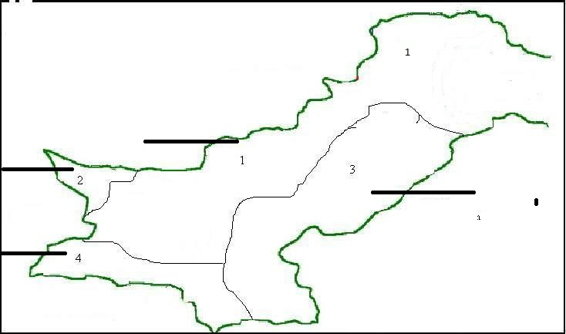
- Which area experiences Monsoon rainfall? /1
_________________________________________________________________________________
- Explain the climate condition of area 4. /2
__________________________________________________________________________________________________________________________________________________________________
Q2) Read the following table and answer the given questions.
City | Tons of waste per day | % of plastic waste | % of food waste | % of metal waste
Karachi | 6632 | 6.4 | 21 | 0.75
Peshawar | 564 | 3.7 | 13.8 | 0.3
Faisalabad | 902 | 0.2 | 17.2 | 0.2
Hyderabad | 756 | 3.6 | 20 | 0.75
Quetta | 247 | 8.2 | 14.3 | 0.2

- Give one reason why Karachi produces the largest amount of waste per day? /1
______________________________________________________________________________
- What are the 2 factors which lead to lack of satisfactory planning? /2
__________________________________________________________________________________________________________________________________________________________________
- What are two problems associated with the growth of cities? /2
___________________________________________________________________________________________________________________________________________________________________________________________________________________________________________________

Q3a) What is the meaning of the term ‘Cantonments?’ /1
______________________________________________________________________________________________________________________________________________________________________________
b: “Cantonments in the 18th and 19th Century were usually used as temporary military quarters”. Why? Discuss the birth of cantonments in detail. /4
________________________________________________________________________________________________________________________________________________________________________________________________________________________________________________________________________________________________________________________________________________________________________________________________________________________________________________________________________________________________________________________________________________________________________________________________________________________________________________________________________________________________________________________
Q4a) Look at the graph & answer the questions written below: /4

- What is this graph representing? ___________________________________________________
- Which is the hottest month? ______________________________________________________
- On which zone is Pakistan located? _________________________________________________
Q5a) Define the term Infant Mortality rate. /1
______________________________________________________________________________________________________________________________________________________________________________
b. Who started this Orangi Pilot project? How has it solved the problems of people living in Orangi? /5
_______________________________________________________________________________________________________________________________________________________________________________________________________________________________________________________________________________________________________________________________________________________________________________________________________________________________________________________________________________________________________________________________________________________________________________________________________________________________________________________________________________________________________________________________________________________________________________________________________________

