The City School
North Nazimabad Boys Branch
Grade 8th
Geography (Blog Sheets) – Summer Vacations

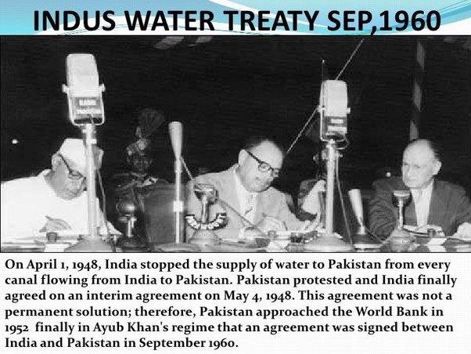

Sheet #1
Give reasons for signing of Indus Water Treaty:
______________________________________________________________________________
______________________________________________________________________________
______________________________________________________________________________
______________________________________________________________________________
______________________________________________________________________________
______________________________________________________________________________
______________________________________________________________________________
______________________________________________________________________________
______________________________________________________________________________
Sheet #2
Study the Wheat crop data and analyze trends as mentioned below: 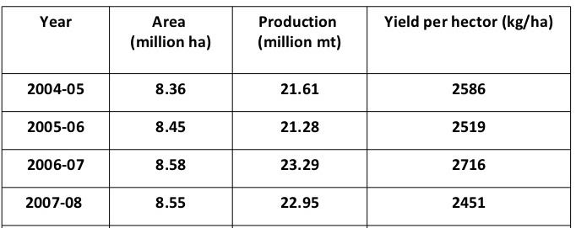
- Changes in Area (million ha):
_____________________________________________________________________________
_____________________________________________________________________________
_____________________________________________________________________________
_____________________________________________________________________________
- Changes in Production (million tonnes):
_____________________________________________________________________________
_____________________________________________________________________________
_____________________________________________________________________________
_____________________________________________________________________________
- Changes in Yield per hector (kg per hector):
_____________________________________________________________________________
_____________________________________________________________________________
_____________________________________________________________________________
_____________________________________________________________________________
Sheet #3
Population of Pakistan, as shown in graph below:
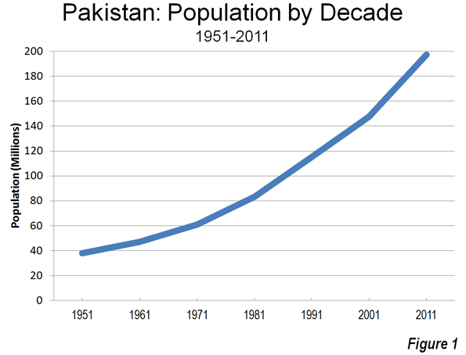
Population each year:
1951: _______________________________
1961: _______________________________
1971: _______________________________
1981: _______________________________
1991: _______________________________
2001: _______________________________
2011: _______________________________

Find out reasons of rapid growth of population in Pakistan:
_____________________________________________________________________________
_____________________________________________________________________________
_____________________________________________________________________________
_____________________________________________________________________________
_____________________________________________________________________________
_____________________________________________________________________________
_____________________________________________________________________________
_____________________________________________________________________________
Sheet #4
Write down definitions of following terms:
Geography: _____________________________________________________________________________
_____________________________________________________________________________
Urban Areas: _____________________________________________________________________________
_____________________________________________________________________________
Rural Areas: _____________________________________________________________________________
_____________________________________________________________________________
Town Planning: _____________________________________________________________________________
_____________________________________________________________________________
Coastal Areas: _____________________________________________________________________________
_____________________________________________________________________________
Port City: _____________________________________________________________________________
_____________________________________________________________________________
Migration: _____________________________________________________________________________
_____________________________________________________________________________
Economic Migration: _____________________________________________________________________________
_____________________________________________________________________________
Social Migration: _____________________________________________________________________________
_____________________________________________________________________________
Sheet #5
Write down definitions of following terms:
Religious Migration: _____________________________________________________________________________
_____________________________________________________________________________
Refugees: _____________________________________________________________________________
_____________________________________________________________________________
Emigrants: _____________________________________________________________________________
_____________________________________________________________________________
Water Logging: _____________________________________________________________________________
_____________________________________________________________________________
Salinity: _____________________________________________________________________________
_____________________________________________________________________________
Sodic Soils: _____________________________________________________________________________
_____________________________________________________________________________
Swamp Areas: _____________________________________________________________________________
_____________________________________________________________________________
Deltaic Areas: _____________________________________________________________________________
_____________________________________________________________________________
Mangroove Forests/Trees: _____________________________________________________________________________
_____________________________________________________________________________
Sheet #6
Write down definitions of following terms:
Prop Roots: _____________________________________________________________________________
_____________________________________________________________________________
Spawning Areas: _____________________________________________________________________________
_____________________________________________________________________________
Dying Indus Delta: _____________________________________________________________________________
_____________________________________________________________________________
Economic Development: _____________________________________________________________________________
_____________________________________________________________________________
Social Development: _____________________________________________________________________________
_____________________________________________________________________________
Hydro Electric Power (HEP): _____________________________________________________________________________
_____________________________________________________________________________
Bio-Mass: _____________________________________________________________________________
_____________________________________________________________________________
Bio-Fuels: _____________________________________________________________________________
_____________________________________________________________________________
Mechanization: _____________________________________________________________________________
_____________________________________________________________________________

