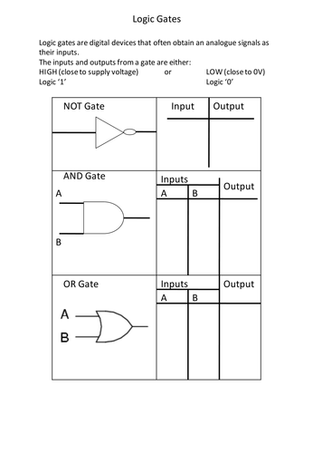
Topic: Logic Gates Level: 8 Date: 17/August/2018 Teacher: Shumaila Ali

