North Nazimabad Boys Campus
Summer Break Blog Worksheet
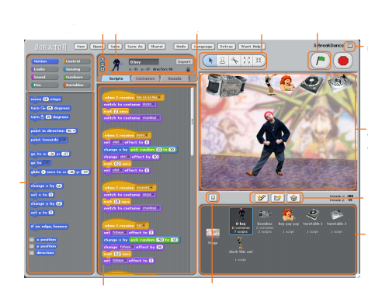
Q.1 Label the following icons. Class 8

Q.2 Define
1.Block Palette __________________________________________________________________________________________________________________________________________________________________________
2. Sprite __________________________________________________________________________________________________________________________________________________________________________
3. Costume __________________________________________________________________________________________________________________________________________________________________________
4. Presentation Mode __________________________________________________________________________________________________________________________________________________________________________
Q.3 Write the name of different tools
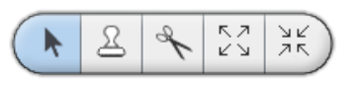
______________________________________________________________________________________________________________________________________________________________________________________________________________________________________________________________________________________________________________________________________________________________________________________________________
Q.4 What are the different types of Blocks? Name them and also briefly explain them.
______________________________________________________________________________________________________________________________________________________________________________________________________________________________________________________________________________________________________________________________________________________________________________________________________________________________________________________________________________________________________________________________________________________________________________________________________________________________________________________________________________________________________________________________

