North Nazimabad Boys Campus
Summer Break Blog Worksheet
Topic = Scratch Level = 8 Subject = ICT
Q.1 What do you mean by Block Palette?
____________________________________________________________________________________________________________________________________________________________
Q.2 What is the purpose of Green Flag?
____________________________________________________________________________________________________________________________________________________________
Q.3 Explain different buttons of Rotation Style.
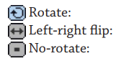
Q.4 Write the name of different tools of toolbar also write the function of tools.
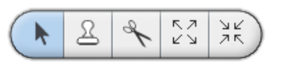
______________________________________________________________________________________________________________________________________________________________________________________________________________________________________________________________________________________________________________________________________________________________________________________________________________________________________________________________________________________________________________________________________________________________________________________________________________________________________________________________________________________________________________________________
Q.5 What are the different types of Blocks? Name them and also briefly explain them.
__________________________________________________________________________________________________________________________________________________________________________________________________________________________________________________________________________________________________________________________________________________________________________________________________________________________________________________________________________________________________________________________________________________________________
Q.6 Label the Paint Editor.
