The City School
Blog WORKSHEET # 5
GRADE 8 Science – Summer Vacations

Q.1: Choose the best answer:
i) The enzyme that breaks down fats into fatty acids and glycerol is_________.
a) carbohydrase
b) lipase
c) protease
d) sucrase

ii) A deficiency of vitamin C in the diet causes a disease called_________.
- Anaemia
- Scurvy
- Rickets
- Goiter

iii) Gastric juice contains __________.
- Sulphuric acid
- Nitric acid
- Hydrochloric acid
- Carbonic acid

iv) When we add some Biuret solution to a food containing protein, the solution will change from
- Light blue to green
- Light blue to purple
- Light blue to dark blue
- Light blue to purple

v) Milk is a rich source of the following nutrients except ___________.
a) iron
b) calcium
c) protein
d) carbohydrate

/3]

DIET PROBLEM DAMAGE IN BODY

High fat and sugar diet Can leads to obesity

High salt diet Not enough vitamins to keep body fit

A diet with no fruits or vegetables Can cause increase in blood pressure

Q.3 Write a sentence to explain the word ‘digestion’.
Q.4 Explain why;
a) Eating breakfast can actually help you to lose weight.
b) Molecules need to be broken down before they get into the body.
c) We need water in our diet .

Q.5 The diagram shows the human digestive system.

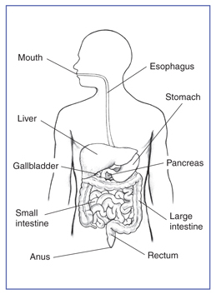
Which of the parts labeled above does each of these jobs?
- Absorbs water ____________
- Produces bile ____________
- Contains hydrochloric acid ____________
- Absorbs digested food ____________

