Unit: Weather and Climate

Weather

Weather is the combination of the current meteorological components e.g. temperature, wind direction and speed, amount and type of precipitation, sun shine hours etc. at a particular place over a short period of time (from one up- to several weeks)

Weather condition is describing typical weather phenomena e.g. a series of blizzards in winters or a rainy day in late summers.

Climate

Climate is the average weather conditions of a specific area over a long period of time (minimum 30 years) e.g. maritime climate, tropical climate etc.

Components of Climate

• Temperature
• Wind speed and direction
• Air Pressure
• Humidity
• Evapotranspiration
• Precipitation
• Condensation
• Cloud cover
• Radiation

Class 8 Project
The Material
The Earth ’s Climatic Zones
There are four major climatic zones in the world.
They are:
Tropical Zone: This region lies between the equator and both the tropics (From 0° to 23.5° North and South) The solar radiation reaches the ground almost vertically at noontime during the entire year. Due to this, it is very warm in this region. Through high temperatures, more water evaporates and the air is often moist. This results in frequent and dense cloud cover which reduces the effect of solar radiation on ground temperature. This zone is also called the
‘Torrid Zone.’
Temperate Zone: This zone lies between 23.5° North to 66.5° North to the North of Equator (North Temperate Zone) and 23.5° South and 66.5° South of the Equator (South Temperate Zone). This zone has the highest variation in temperatures.
The sub-tropical areas between 23.5° North to 40° North and 23.5° South to 40° South, receive the highest radiation in summer, since the Sun’s angle at noon is almost vertical to the Earth, whereas the cloud cover is relatively thin. These regions receive less moisture which increases the effect of radiation. Therefore, most of the deserts in the world are
situated in this zone. In winters, the radiation in these regions decreases significantly and it can temporarily be very cool and moist.
From 40° North to 60° North and 40° South to 60° South, the solar radiation reaches with a smaller angle and the average temperatures here are much cooler than in the sub-tropics. The seasons and the length of the day differ significantly in the course of a year. The climate is characterized by less frequent extremes, a more regular distribution of the precipitation over the year and a longer vegetation period therefore the name ‘temperate.’
Polar Zone: This zone lies from 60° North to 90° North and is called the North Polar Zone and from 60° South to 90° South called the South Polar Zone. These areas receive less heat through solar radiation, Since the Sun has a very flat angle toward the ground. Because of the changes in the angle of the axis of Earth to the Sun, the length of the day varies most in this zone. In the summer of each hemisphere, the polar days occur. This zone is also called the Frigid Zone.
Below is the diagrammatic representation of the Earth’s Climate Zones.
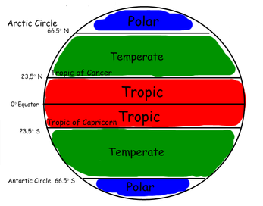
Fig 1
World Map showing the ‘Climate Zones of the Earth’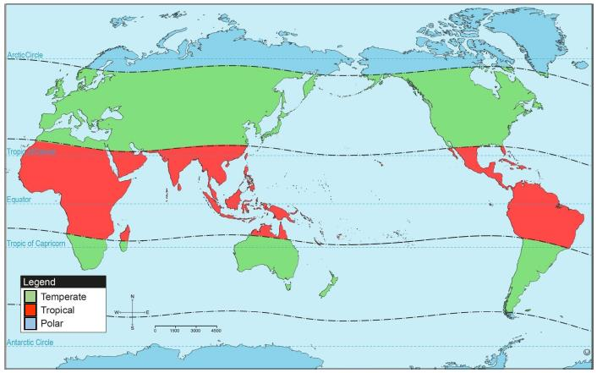
Fig 2
Weather and Climate of Pakistan
Pakistan lies in the Temperate Zone. The climate is generally arid, having hot summers and cool to cold winters. There are wide variations between extremes of temperatures at given locations. On the whole, the rainfall is little and it can be unreliable; sometimes coming early sometimes late. The overall amount may also vary.
Pakistan recorded one of the highest temperatures of the world i.e. 53°C on 26 May, 2010. Pakistan lies a little to the north of Tropic of Cancer, a fact that places Pakistan in the Temperate Zone. It has a continental type of climate which means that there are great variations in its temperature, both seasonal and diurnal. (Diurnal means daily)
Climatic Zones
Pakistan has a vast latitudinal extent. The northern and western parts consist of lofty mountains and hills. There are lowlands, plateaus and coastal areas. Due to the topographical diversity, Pakistan experiences a variety of climate. The four climatic divisions of Pakistan are:
- Highland Climate Zone B. Lowland Climate Zone C. Coastal Climate Zone D. Arid Climate Zone
- It is important to remember that classifying a place in a climatic zone does not suggest that the whole zone will have the same climate. Within a zone, there will be variations in the amount of rainfall, temperature, humidity, winds etc. The best example of this is the northern and western highlands of Pakistan which fall in the same climatic zone but the amount of rainfall and temperature is different within the zone.
- The Seasons
- Pakistan has four seasons which are:
- a. Winter (mid-December to March) - b. Early Summer (April to June)
- c. Late Summer or Monsoon (July to September)
- d. Post Monsoon (October to mid December)

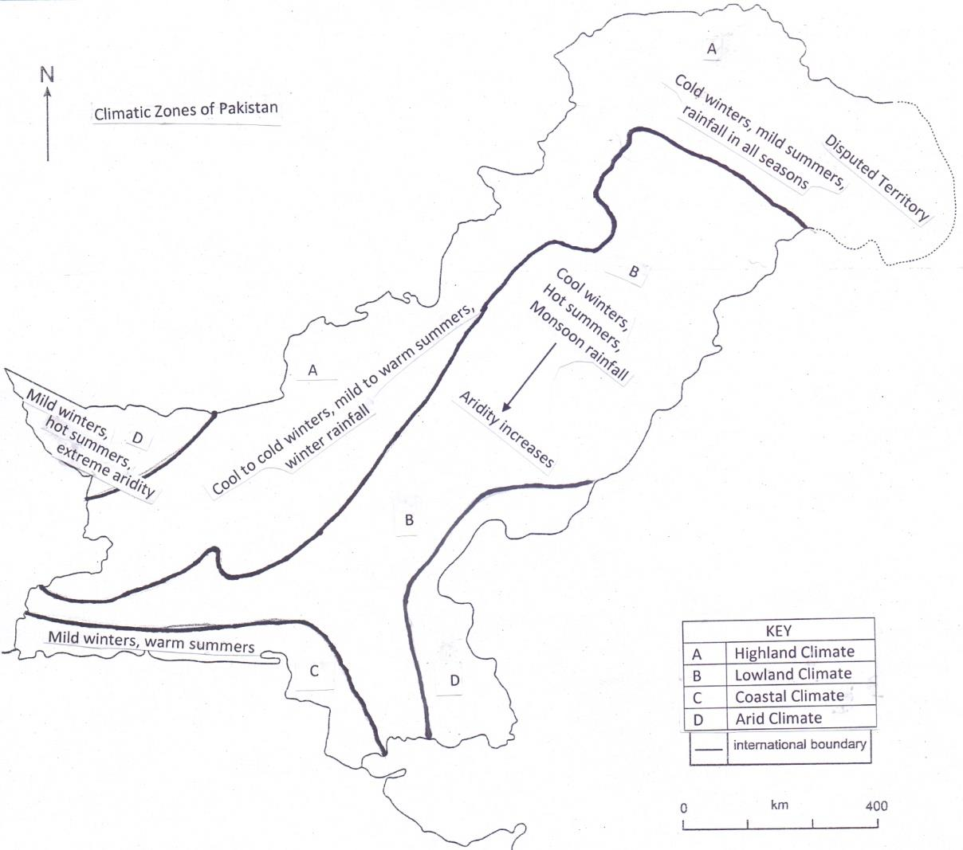

Rainfall
Most of the areas in Pakistan are arid or semi-arid. Humid conditions are found in the northern areas of Pakistan. As we move from the north to the south of Pakistan, the rainfall decreases.
Sources of Rainfall
These are:
a. Monsoon rainfall: One of the major sources of rainfall in Pakistan, monsoon winds are seasonal winds, which bring heavy rainfall. These winds blow from the Bay of Bengal and cross Bangladesh and India before reaching Pakistan and lose most of their moisture in these countries. Northern Pakistan gets the tail end of these winds and receive rainfall from July to September. Sometimes the over active monsoon system brings heavy rainfall in Karachi and the coast of Sindh.
b. Western depressions or cyclones: These originate in the Mediterranean Sea and travel across the landmasses of Afghanistan and Iran before reaching the western areas of Pakistan. Peshawar gets the maximum of rainfall from this source but as the winds move towards western and south-western parts of the country, they lose their moisture already. The rainfall in these areas come from December to March.
c. Convectional currents causing thunderstorms: Only the northern and north-western
areas of Pakistan receive rainfall from convectional currents. When hot, moist air rises and reaches the higher layers of the atmosphere, condensation begins which causes rainfall.
d. Relief rainfall: Relief rainfall occurs when the moist air moves up a cool to cold mountain. Low temperature causes precipitation.
e. Tropical cyclones: These occur on the coastal areas and may bring heavy rainfall for a
few hours. They originate over the Arabian Sea quite often but usually they don’t make landfall in Pakistan but are diverted to India, Oman or Iran. Each year before the monsoon season and after its withdrawal, there is always a distinct possibility of the cyclonic storm to develop in the north Arabian Sea. Cyclone Phet in 2010 was the wettest cyclone so far in Pakistan.
Reading Graphs
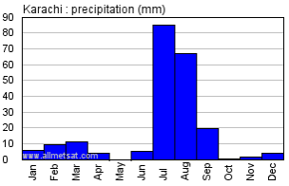
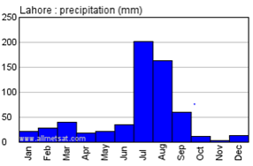

These are rainfall graphs of two locations in Pakistan; Karachi and Lahore. They show an annual pattern of rainfall in both the cities. Study the graph of each city and then compare both the graphs.
Which city has more rainfall in the month of July? The answer is Lahore. Look at the scale of X axis of the graph. Lahore has 200 mm of rainfall whereas Karachi has 85 mm of rainfall. When reading a graph, consider these questions.
a. Which is the wettest month? (The month receiving the maximum rainfall)
b. Which is the driest month? (The month receiving the minimum rainfall)
c. What is the pattern of rainfall? (Does the place receive rainfall all year long? Is the rainfall equally distributed or concentrated in a month or months?
d. What is the yearly average? (Calculate the average of rainfall from January to
December)
After you get this information, you can go one step further. Ask yourself why does a place have a certain pattern of rainfall? Why only in monsoon months? Or why the place receives rainfall throughout the year?

Now copy and paste the given link on google and find out rainfall graphs of any two cities and
interpret the same using the guidelines from ‘a to d’.

http://www.eldoradocountyweather.com/climate/pakistan/pakistan-climate-listings-a-z.html

These graphs show the temperature of two cities; Sibi in Balochistan and Drosh in Khyber Pakhtunkhwa. The red line shows the maximum monthly temperature and the blue line shows the minimum monthly temperature of both the cities. Which city has the highest temperature? Which city has the lowest temperature? Which month has the maximum difference between the minimum and maximum temperatures? Are there warmer months more as compared to cooler months or vice versa? Study the graph of each city and then compare both the graphs. Consider these questions while you read the graphs.

a. Which is the hottest month?
b. Which is the coldest month?
c. Are there more warm/hot months or cool/cold months?
d. Which month has the maximum difference between the minimum and maximum temperatures?
After you get this information, you can go one step further. Ask yourself why does a place have a certain pattern of temperature?
Now copy and paste the given link on google and find out the maximum and minimum temperature graph of any two cities and interpret the same using the guidelines from ‘a to d’.
http://www.eldoradocountyweather.com/climate/pakistan/pakistan-climate-listings-a-z.html

