The City School
North Nazimabad Boys Campus
Syllabus Breakup of ICT
Class 7 | Class 8
- Scratch  - Algorithms and Flowchart  - Introduction to HTML  - Elementary HTML I  - Elementary HTML II | - Scratch  - Algorithms and Flowchart  - Flash- Tweening and Publishing

Learning Objectives:
Class 7
- Scratch
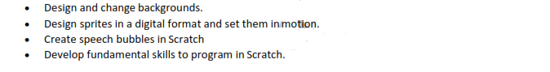
- Algorithms and Flowchart
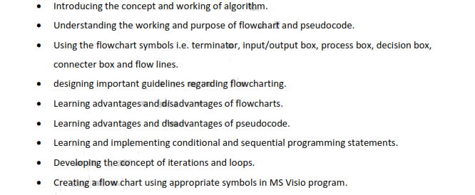
- HTML
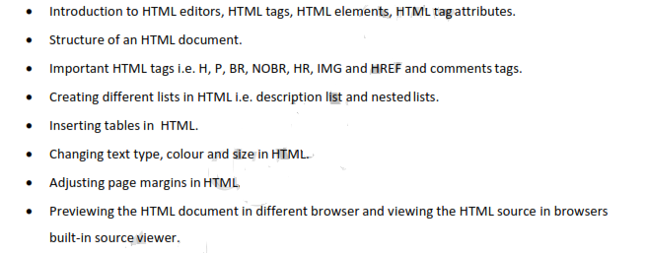

Class 8
- Scratch:
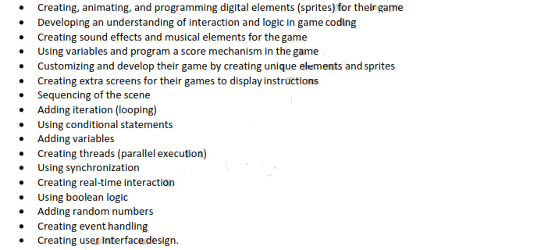
- Algorithms and Flowchart:
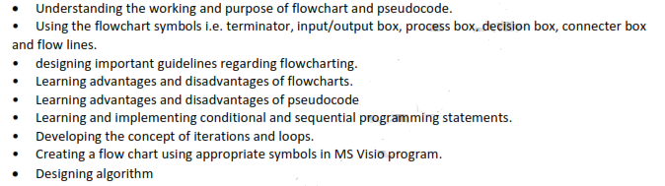
- Flash
