The City School
North Nazimambad Campus
Name: _____________ Grade: 7

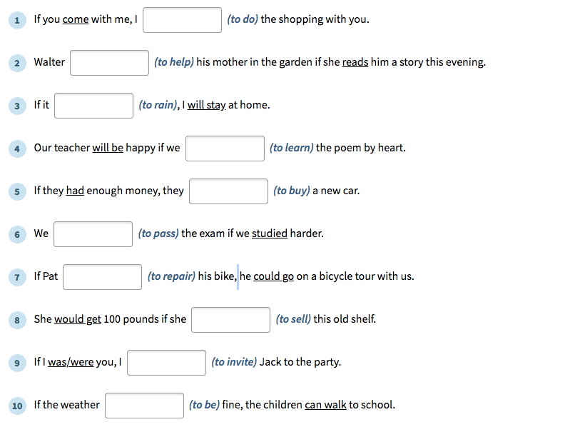
Put in the verbs in brackets and form Conditional sentences

