**Let’s meet EdPy**



**The Edison robot can also be programmed with a programming language called EdPy. EdPy is a text-based programming language based on Python and its application can be used online without any installation on your computer.**

Visit [www.edpyapp.com](http://www.edpyapp.com/) in order to be familiarized with the programming environment of **EdPy**. Before you get started, choose the version of your Edison robot.

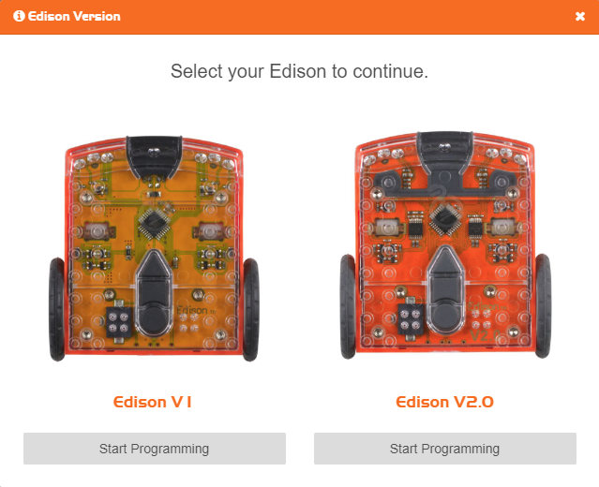

|  |
| --- |
| **Fill in the gaps with the labels below describing the components of the EdPy user interface.** |
| **Help – Download the program – Programming area – Example programs – Check code – Menu button – Compiler output** |

























