Teacher Name: Azka Sadia Class 8 Subject: English Date: 22nd November 2019
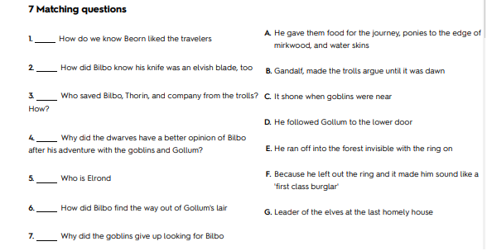
TOPIC: Hobbit chapter (1-7) Worksheet # 1
