Teacher Name:Rashida Arif Class:7 Subject: English Date:06/10/2018
Topic: Punctuation
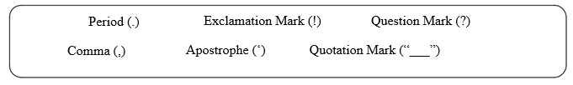
Directions Re-write each sentence below and add the correct punctuation mark or marks where needed.

- I am so excited to see my family for Christmas ______

- Where is an exciting place to visit ______

- Make sure to complete all your homework on time ______

- John asked when we are going on a vacation ______

- Terry Sam and Jeremy went to the movies together ______

- Wow ______ What a wonderful event _____

