Teacher Name: Zunayyara Class: 6 Subject:Geography Date:22-3-19
Q1.Read the graph and answer the following questions.

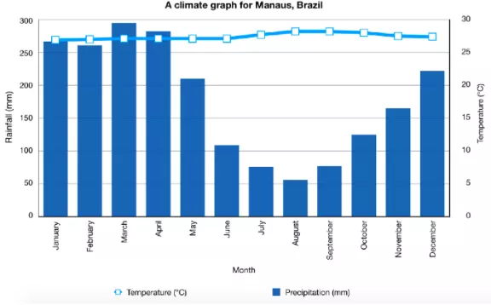

a.Name five months in which there is maximum rainfall.
Ans.______________________________________________________________________________
__________________________________________________________________________________
__________________________________________________________________________________
__________________________________________________________________________________
__________________________________________________________________________________
__________________________________________________________________________________
b.What is the temperature range of this type of vegetation.
Ans._____________________________________________________________________________
c.Identify the type of vegetation.
Ans._____________________________________________________________________________
d.According to the graph,discuss the characteristics of the identified vegetation.
Ans.______________________________________________________________________________
__________________________________________________________________________________
__________________________________________________________________________________
__________________________________________________________________________________
__________________________________________________________________________________
__________________________________________________________________________________
__________________________________________________________________________________
__________________________________________________________________________________
__________________________________________________________________________________
__________________________________________________________________________________
__________________________________________________________________________________
__________________________________________________________________________________
__________________________________________________________________________________
e.Observe the map and mention the type of trees found in different provinces of Pakistan.
.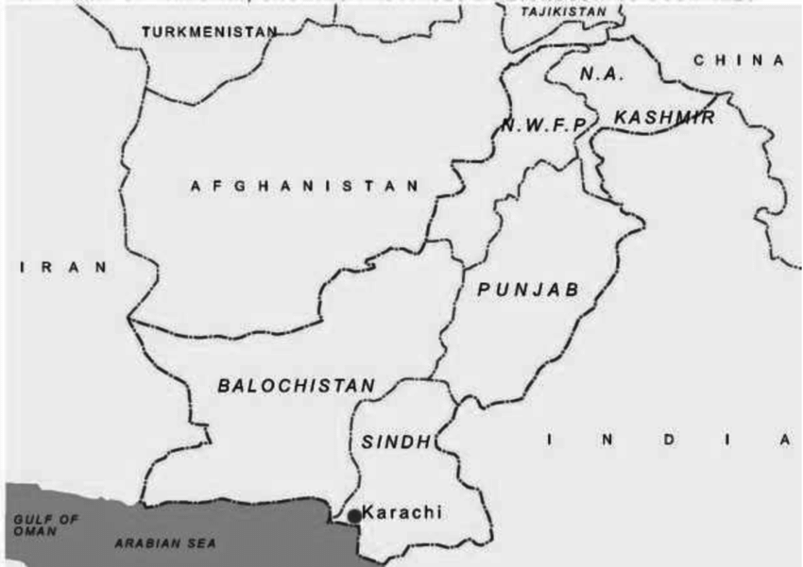

f. Describe the characteristics of the scrub vegetation in Pakistan.
Ans.______________________________________________________________________________
__________________________________________________________________________________
__________________________________________________________________________________
__________________________________________________________________________________
__________________________________________________________________________________
__________________________________________________________________________________
__________________________________________________________________________________
__________________________________________________________________________________
g.Highlight some characteristics of Tropical Grassland and Desert Vegetations.
Ans.______________________________________________________________________________
__________________________________________________________________________________
__________________________________________________________________________________
__________________________________________________________________________________
__________________________________________________________________________________
__________________________________________________________________________________
__________________________________________________________________________________
__________________________________________________________________________________
h.Discuss why people should conserve the natural vegetation. How is it helpful to land and people.
Ans.______________________________________________________________________________
__________________________________________________________________________________
__________________________________________________________________________________
__________________________________________________________________________________
__________________________________________________________________________________
__________________________________________________________________________________
__________________________________________________________________________________
__________________________________________________________________________________

i. What are the reasons to destruct natural vegetation? How does it affect the land, people and animals?

Ans.______________________________________________________________________________
__________________________________________________________________________________
__________________________________________________________________________________
__________________________________________________________________________________
__________________________________________________________________________________
__________________________________________________________________________________
__________________________________________________________________________________
__________________________________________________________________________________

