Teacher Name: Junaid Liaquat Ali Class: 08 Subject: Geography Date: 04-2-2019.

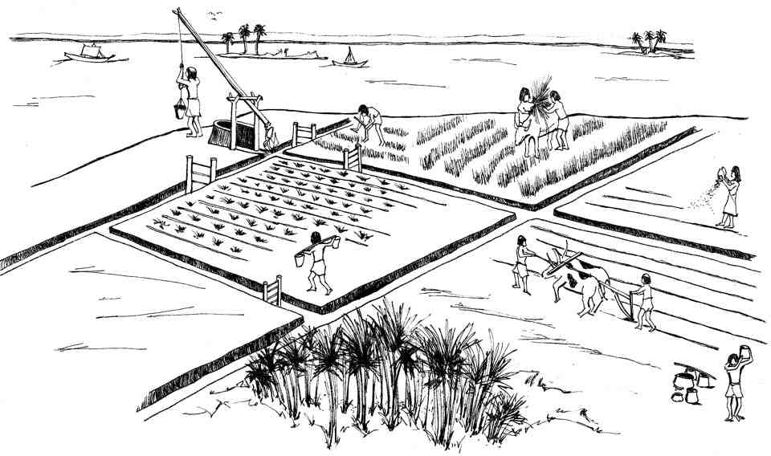
Look at the picture & explain what activities are shown in the diagram in your words:

Answer:
.

