The City School
Summer Vacation
Subject Geography
Class 8
Resource Worksheet
Name: __________________ Sec: _______ Date: _______________

Q1. Look at the map given below and answer the relevant questions
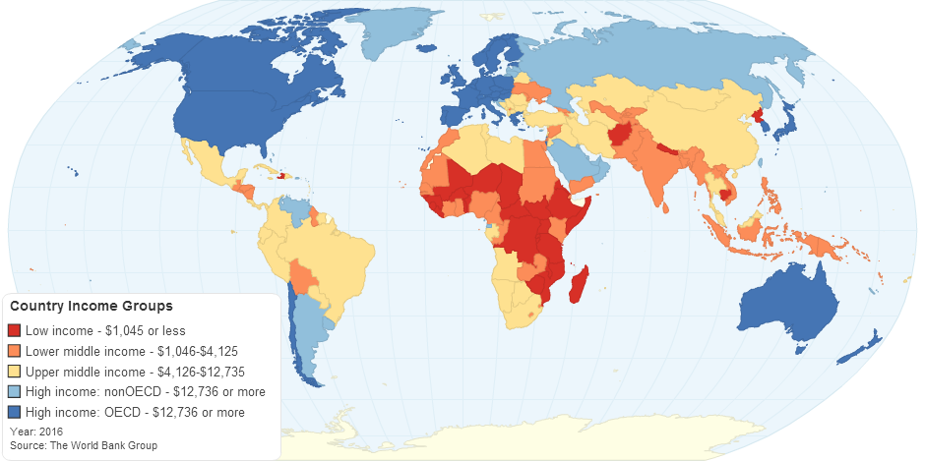
a. What is meant by Third World countries?
______________________________________________________________________________________________________________________________________________________________________________________________________________________________________________________________________________________________________________________________________________________________________________________________________
i. What is meant by high income countries?
______________________________________________________________________________________________________________________________________________________________________________________________________________________________________________________________________________________________________________________________________________________________________________________________________
ii. How levels of development can be measured?
____________________________________________________________________________________________________________________________________________________________________________________________________________________________________________________________________________________________________________________________________________________________________________________________________________________________________________________________________________________

