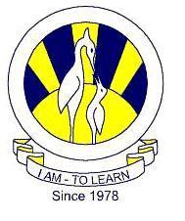The City School
Summer Vication
Subject Geography
Class 8
Resource Worksheet

Name: __________________ Sec: _______ Date: _______________

Social and Economic development are interrelated
i. Draw a flow chart showing the relationship between the both;

ii. Why do countries want to develop?
______________________________________________________________________________________________________________________________________________________________________________________________________________________________________________________________________________________________________________________________________________________________________________________________________
Q2. a. Explain Saudi Arabia’s Third development Plan.
____________________________________________________________________________________________________________________________________________________________________________________________________________________________________________________________________________________________________________________________________________________________________________________________________________________________________________________________________________________

