The City School
Summer Vacation
Subject Geography
Class 8
Resource Worksheet
Name: __________________ Sec: _______ Date: _______________
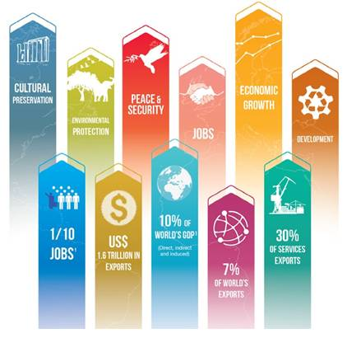
i. Write effects of tourism in detail. ____________________________________________________________________________________________________________________________________________________________________________________________________________________________________________________________________________________________________________________________________________________________________________________________________________________________________________________________________________________
ii. Explain attempts of social developments in Pakistan as per SAP.
______________________________________________________________________________________________________________________________________________________________________________________________________________________________________________________________________________________________________________________________________________________________________________________________________

iii. Explain attempts of social developments as per SDGs.
______________________________________________________________________________________________________________________________________________________________________________________________________________________________________________________________________________________________________________________________________________________________________________________________________

