The City School
Summer Vacation
Subject Geography
Class 8
Resource Worksheet
Name: __________________ Sec: _______ Date: _______________
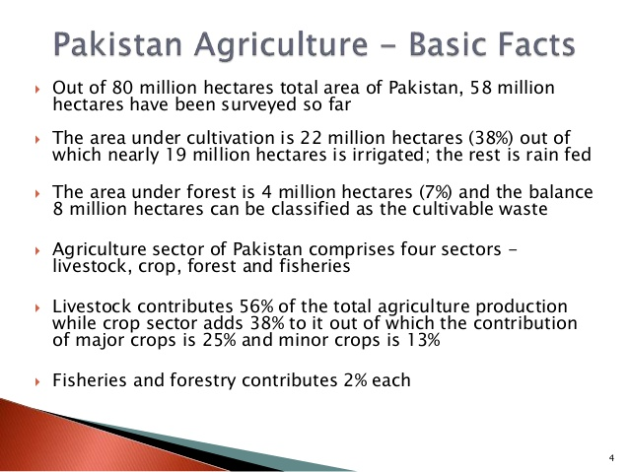

Question: In the light of above mention facts suggest how Pakistan can further improve its agriculture in a sustainable way…
Answer: _________________________________________________________________________________________________________________________________________________________________________________________________________________________________________________________________________________________________________________________________________________________________________________________________________________________________________________________________________________________________________________________________________________________________________________________________________________________________________________________________________________________________________________________________________________________________________________________________________________________________________________________________________________________________________________________________________________________________________________________________________________________________________________________________________________________________________________________________________________________________________________________________________________________________________________________________________________________________________

