Teacher Name: Zunayyara Class: 6 Subject: Geography Date:14-9-2018
Q1. Define atmosphere.
Write down the composition of air with their percentages.
______________________________________________________________________________________________________________________________________________________________________________
______________________________________________________________________________________________________________________________________________________________________________
______________________________________________________________________________________________________________________________________________________________________________
______________________________________________________________________________________________________________________________________________________________________________
______________________________________________________________________________________________________________________________________________________________________________
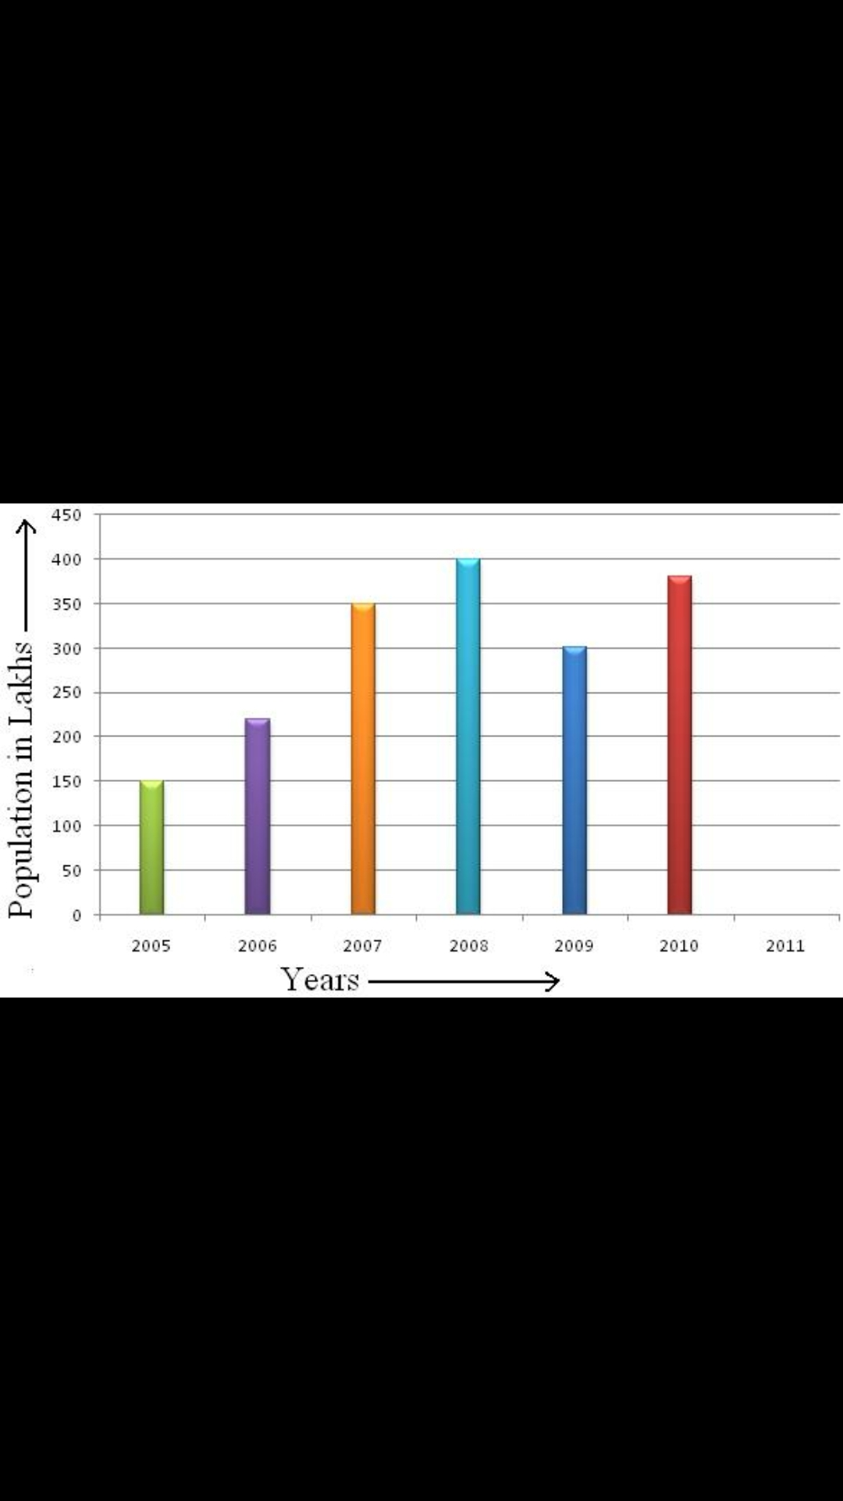
Q2. Observe the graph and answer the following que question

1. Which month of the year is showing the maximum population?
_______________________________________________________________________________________2. In which month the population is 150?
_______________________________________________________________________________________3. Which month has the minimum population?
_______________________________________________________________________________________4. In the year 2010, how much population is shown?
_______________________________________________________________________________________

