Teacher Name:Zunayyara Class:6 Subject: Geography Date:7-9-2018

Q2.Describe the types of maps according to their uses.
___________________________________________________________________________________________________________________________________________________________________
_________________________________________________________________________________
_________________________________________________________________________________
_________________________________________________________________________________
_________________________________________________________________________________
_________________________________________________________________________________
_________________________________________________________________________________
_________________________________________________________________________________

_________________________________________________________________________________
_________________________________________________________________________________
_________________________________________________________________________________
_________________________________________________________________________________

_________________________________________________________________________________
_________________________________________________________________________________
_________________________________________________________________________________
_________________________________________________________________________________

_________________________________________________________________________________
_________________________________________________________________________________
_________________________________________________________________________________

_________________________________________________________________________________
_________________________________________________________________________________
_________________________________________________________________________
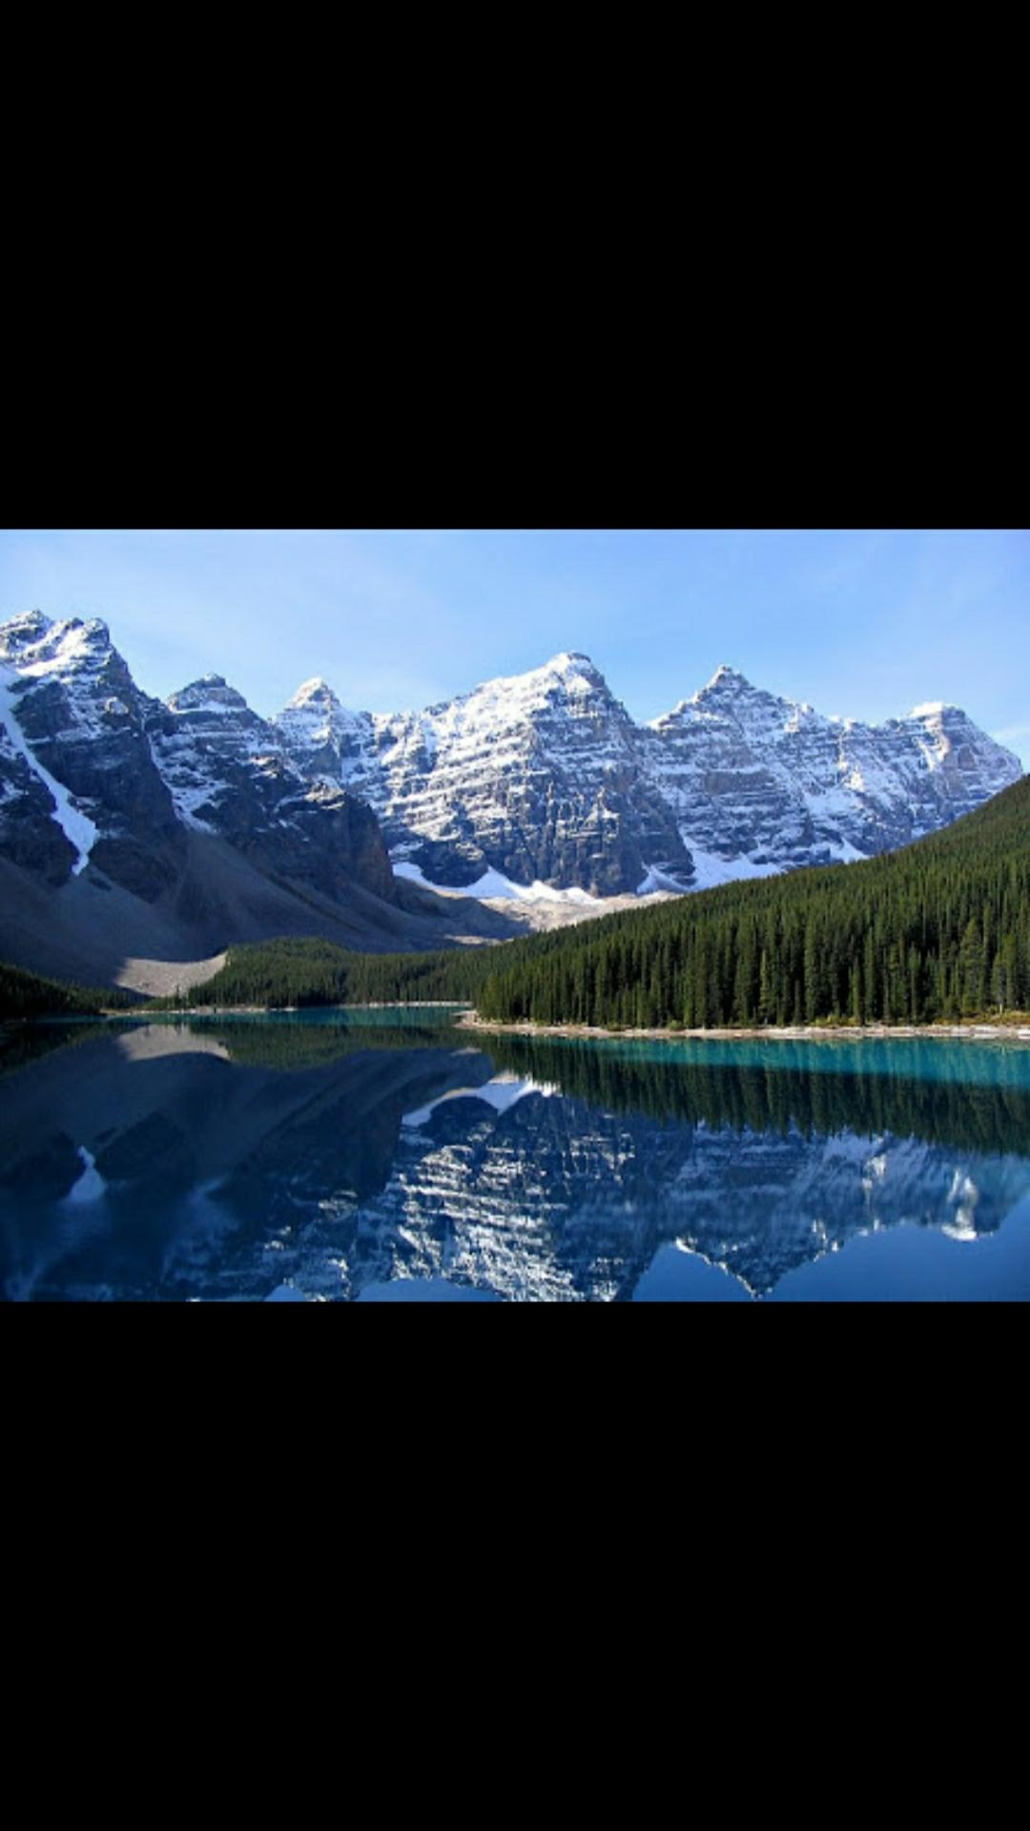
Q. Describe the scene using appropriate terms e.g. foreground, background, left-hand side, right-hand side, middle ground.
