Teacher Name: Ms.Kiran Haq Class: 7 Subject: History Date: 1st-Mar-2019
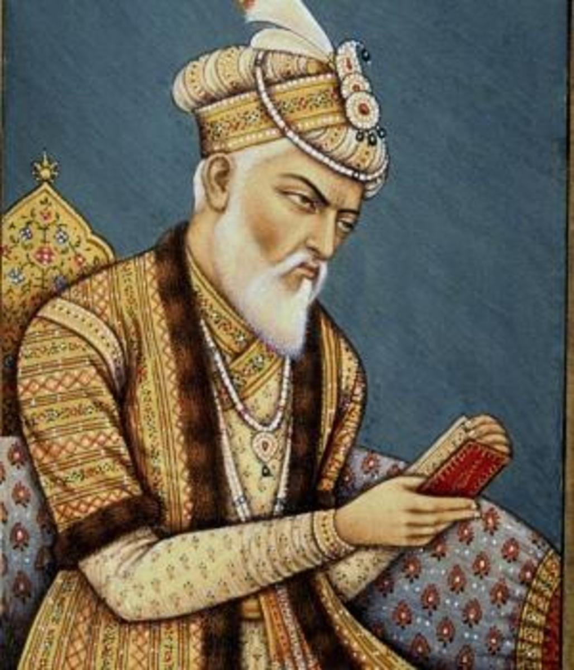
Use the given source to answer the following questions.
- Identify the personality in the given source.
Ans: ___________________________________
- What was the title given to him?
Ans: ___________________________________
- Highlight the main aspects of his rule.
Ans:________________________________________________________________________________________________________________________________________________________________________________________________________________________________________________________________________________________________________________________________________________________________________________________________________________________________________________________________________________________________________________________________________________________________________________________________________________________________________________________________________________________________________________________________________________________________________________________________________________________________________________________________________________________________________________________________________________________________________________

