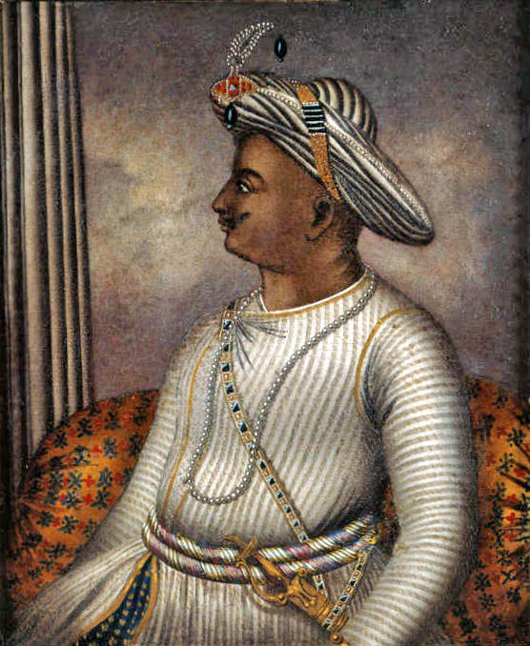
Teacher Name: Ms.Kiran Haq Class: 7 Subject: History Date: 12th-April-2019

Use the given source to answer the following questions.
- Identify the personality in the given source.
Ans: ___________________________________
- What was the title given to him?
Ans: ___________________________________
- Give an account on his life and rule.
Ans:________________________________________________________________________________________________________________________________________________________________________________________________________________________________________________________________________________________________________________________________________________________________________________________________________________________________________________________________________________________________________________________________________________________________________________________________________________________________________________________________________________________________________________________________________________________________________________________________________________________________________________________________________________________________________________________________________________________________________________

