Teacher Name: Ms.Kiran Haq Class: 7 Subject: History Date: 15-Nov-2019
Q1: Use the given source to answer the following questions.

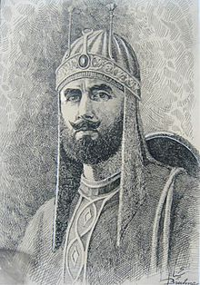
Source A:
(i)Identify the personality in the given source.
Ans:______________________________________________________
(ii)Describe his achievements.
Ans:_____________________________________________________________________________________________________________________________________________________________________________________________________________________________
(iii)Write a note on the ‘Grand Trunk Road’.
Ans;______________________________________________________________________________________________________________________________________________________________________________________________________________________________________________________________________________________________________________________________________________________________________________________________________________________________________________________________

