The City School
Southern Region
Revision Questions
Class 8 ‘HISTORY’

Section A
Picture Source:
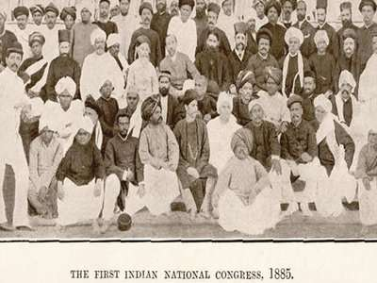
- Who establish Indian National Congress?
- Why was there a need for such a platform?
- How has this platform proved to be important for locals?

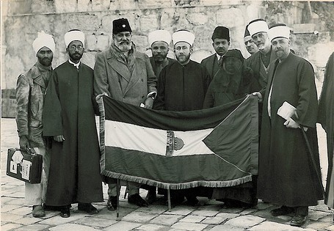
Khilafat Movement
- Why was Khilafat movement started?
- Why Gandhi supported the Khilafat movement?

Written Source
‘Muslim women played an active part in the independence movement by forming the women’s branch of the Muslim League and organizing women and informing them about the politics of the country. They organized public meetings for women and addressed large gathering. They also started educating Muslims girls.’

- How the Muslim women did brought awareness in the society?
- Do you think educating Muslim girls will benefit the community?

‘The Simla deputation proved a landmark in the history of modern India, because for the very first time the Hindu-Muslim conflict, which stared with the Urdu-Hindi controversy, was lifted to the constitutional plane. The Indians were not satisfied with the Indian council Act of 1892. Especially, the act failed to ensure the fair representation of Muslims. So, the Indians were agitating for more power. Due to the growing political pressure and increasing social unrest, the British Government decided to make constitutional reforms relating to the electoral bodies.’
- Why the British decided to make constitutional reforms?
- What was Urdu Hindi controversy?

Section B
4 marks questions
- Who was Chaudari Rehmat Ali?
- What was Canal Water Dispute?
- Explain the concept of Communism.
- How did Hindus reacted towards Bengal partition?
- What were the beliefs of Sir Syed to improve the position of Muslims?
- What was the refugee issue?
- How was the Hyderabad and Junagarh issues resolved?
- Highlight the purpose of holding Round Table Conferences.
- What was suffragette movement?
- Describe the incident of Amritsar Massacre.
6 marks questions
- Why were the Muslims happy with Bengal partition in 1905?
- Discuss the reasons for the outbreak of World War I.
- How has Kamal Pasha modernized Turkey?
- Describe the role of Allama Iqbal in the uplift of Muslim society.
- Explain the impact of 1919 act on Indian politics.
- How did the role of women changes due to suffragette movement?
- Elaborate the role of Rana Liaquate Ali Khan for the betterment of Muslim women.
- Examine the reasons for the establishment of Bangladesh.
- How can we say that Second World War was more deadly than the First World War?
- Discuss the importance of Simla Deputation and Muslim League formation for Indian Muslims.

10 marks questions
- ‘The Khilafat movement effected the political views of Muslims.’ Do you agree? Explain.
- ‘Pakistan was keen to settle the refugee issue.’ Elaborate the role of the government in settling the refugee issue in 1947.
- Analyze how Bengal partition has affected the Hindu community.
- Discuss the role of Congress and Muslim League during the War years.
- Discuss the factors that changed the British views regarding the partition of India.
- ‘Role of women is of prime importance in Pakistan Movement.’ Prove the given statement with examples.

