Teacher Name: Areeba Khurram Baig Class 8 Subject: History Date: October 5th 2019
Use the given source to answer the following questions.
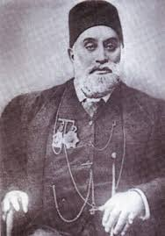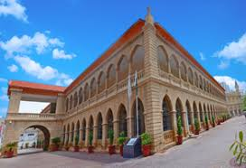
1. According to the given source, what you can recall about the person? 4m
__________________________________________________________________________________________________________________________________________________________________________________________________________________________________________________________________________________________________________________________________________________________________________________________________________________________
2. How was the Sindh Madressa-tul-Isam setup? 6m
________________________________________________________________________________________________________________________________________________________________________________________________________________________________________________________________________________________________________________________________________________________________________________________________________________________________________________________________________________________________________________________________________________________________________________________________________________________________________________________________________________________________________________________________________________________________________________________________________________________________________________________________________________________________________________________________________________________________________________________________________________________

