Teacher Name: Areeba Khurram Baig Class 8 Subject: History Date:October 12th 2019
Use the given source to answer the following questions.

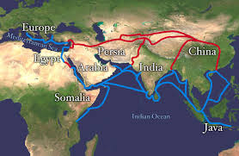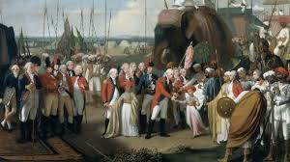

1.What does the given source show about the Company’s establishment in India?
______________________________________________________________________________________________________________________________________________________________________________________________________________________________________________________________________________________________________________________________________________________________________________________________________________________________________________________________________________________________________________________________________________________________________________________________
2. As per the given source, how do you think British established themselves in India?
________________________________________________________________________________________________________________________________________________________________________________________________________________________________________________________________________________________________________________________________________________________________________________________________________________________________________________________________________________________________________________________________________________________________________________________________________________________________________________________________________________

