Teacher Name: Areeba Khurram Baig Class 8 Subject: History Date:October 19th 2019
Use the given source to answer the following questions.
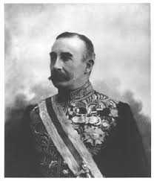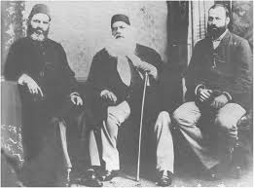

- What event you can recall by looking at the given source?
____________________________________________________________________________________________________________________________________________________________________________________________________________________________________________________________________________________________________________
- How is the event important for the Indian Muslims?
____________________________________________________________________________________________________________________________________________________________________________________________________________________________________________________________________________________________________________________________________________________________________________________________________________________________________________________________________________________________________________________________________________________________________________________________________________________________________________________________________________________________________________________________________________________________________________________________________________________________________________________________________________________________________________________________________

