Revision Questions
Class 7
Section A
Q1a. Read the text carefully and answer the questions below.
Page 8; second paragraph
AL-Khwarezmi was a Persian Muslim scholar ……………………………… as mathematics was his forte.
- What evidence can you find to support the underline phrase in the given passage? /4
- How can you prove that he was internationally acclaimed? /1
- Page 21; Side Heading “Mehmet II”
Mehmet II is famous as the …………………………………………….. Anatolia to his empire.
i. “For a month, Sultan Memet had siege around the Constantinople.” What does this statement tell us
about the capabilities of Sultan Mehmet? /3
ii. How did Sultan Mehmet ruled his empire? /2

b. Study the given source and answer the questions.
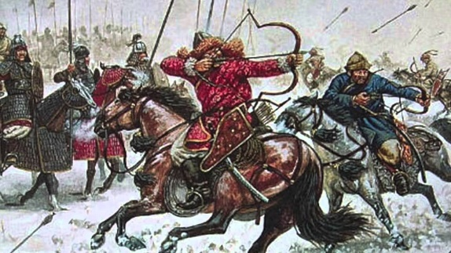
Mongol attacked Baghdad
- Name the Mongol leader who attacked and destroyed Baghdad. /1
- What made you think that halted the Muslims’ spirit to study and creativity? /2
- Identify the two basic principles for study adopted by the Muslim scientists. /2

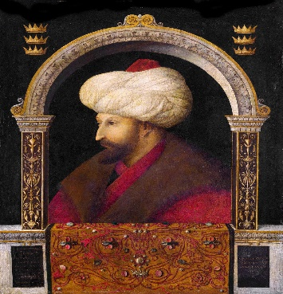
- Identify the personality. /1
- How can we prove that this personality was a just ruler? /4

Section B
Q1a. How can we prove the significance of Al-Razi as a Muslim scholar? /4
b. Do you agree that the era from 661 till 1258, was the Golden era for the Muslims? Support your
answer with appropriate references. /6
Q2a. Describe the Janissary system. /4
- What in your opinion were the reasons of the downfall of Ottoman empire? /6

