Teacher Name: Ms.Kiran Haq Class: 7 Subject: History Date: 19-Jan-2019
Q1: Use the given source to answer the following questions.

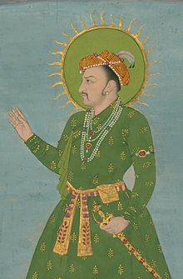
Source A:
(i)Identify the personality in the given source.
Ans:______________________________________________________
(ii)What was the title given to him?
Ans:______________________________________________________
(iii)Describe the main features of his memoirs.
Ans;______________________________________________________________________________________________________________________________________________________________________________________________________________________________________________________________________________________________________________________________________________________________________________________________________________________________________________________________

