Teacher Name: Ms.Kiran Haq Class: 7 Subject: History Date: 25-Jan-2019
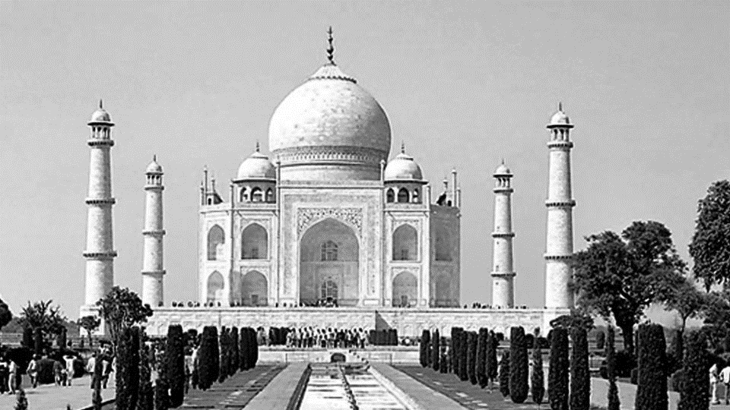
Q1: Use the given source to answer the following questions.

- Identify the source in the given picture?
Ans: ______________________________________________________________________
- Where is it located?
Ans: ______________________________________________________________________
(iii) Who built it?
Ans: ______________________________________________________________________
- What do you know about the specifications of this building?
Ans: ______________________________________________________________________
__________________________________________________________________________
__________________________________________________________________________
__________________________________________________________________________
__________________________________________________________________________
__________________________________________________________________________

