Teacher Name: Ms.Kiran Haq Class: 8 Subject: History Date: 18-Jan-2019
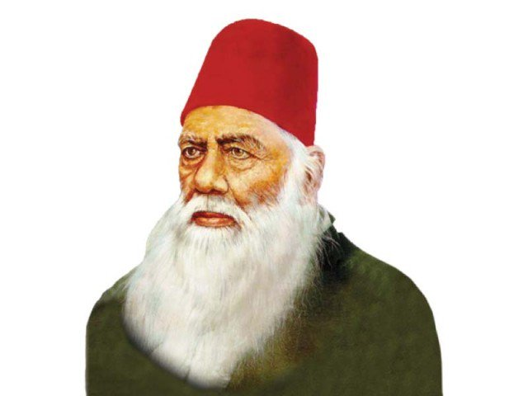
Q1: Use the given source to answer the following questions
- Identify the personality in the given source.
Ans:___________________________________________
- Write about his notable work; ( Name only)
Ans:___________________________________________
_______________________________________________
_______________________________________________
_______________________________________________
- Describe his role in improvising the condition of the Muslims of the sub-continent.
Ans:______________________________________________________________________________________________________________________________________________________________________________________________________________________________________________________________________________________________________________________________________________________________________________________________________________________________________________________________________________________________________________________________________________________________________________________________________________________________________________________________________________________________________________________________________________________________________________________________________________________________________________________________________________________________________________________________________________________________________________________________________________________________________________________________________________________

