Match the selected cells with the corresponding written cells
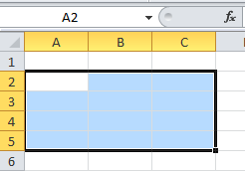 |  |  |  | A3;B4;A5,
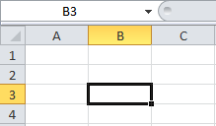 |  |  |  | B3
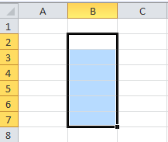 |  |  |  | B2:B7
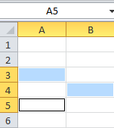 |  |  |  | A2:C5

Teacher Name: Ms Amsa Class: 6 Subject: ICTech Date:25 January, 2019

Match the icons in the left column with the corresponding formatting actions
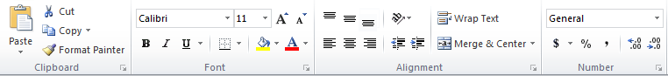
 |  |  |  | Change the type of content
 |  |  |  | Turn the content of the cell into a percentage
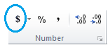 |  |  |  | Align the text to the left, center or right of the cell
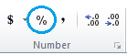 |  |  |  | Turn the content of the cell into currency
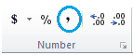 |  |  |  | Decrease the digits after the decimal point
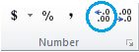 |  |  |  | Increase the digits after the decimal point
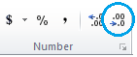 |  |  |  | Turn the content of the cell into a decimal
 |  |  |  | Align the text to the top, center or bottom of the cell

