**Format your web site!**



**Another web language is CSS, and allows us to change the appearance of our web page. The CSS rules have a general syntax:**

Selector {

Property: value;

}

|  |  |  |  |  |  |  |  |  |
| --- | --- | --- | --- | --- | --- | --- | --- | --- |
| **Match the following columns in order to understand the different types of CSS rules there are:** | | | | | | | | |
| Standard selector | ⭘ |  | ⭘ | is applied to as many elements you want | ⭘ |  | ⭘ | #name |
| Id selector | ⭘ |  | ⭘ | is applied to all elements on the entire web page | ⭘ |  | ⭘ | .name |
| Class selector | ⭘ |  | ⭘ | is applied to only one element | ⭘ |  | ⭘ | name |
|  |  |  |  |  |  |  |  |  |

**Now, look at the following code and write down the CSS rules you see:**

|  |  |  |  |
| --- | --- | --- | --- |
|  | **CCS RULES** | | |
| **Code** | **Selector** | **Properties** | **Values** |
| sasasa |  |  |  |
|  |  |  |
|  |  |  |
|  |  |  |

**In the following HTML code there is an inherited CSS rule. Look at it and answer the questions:**

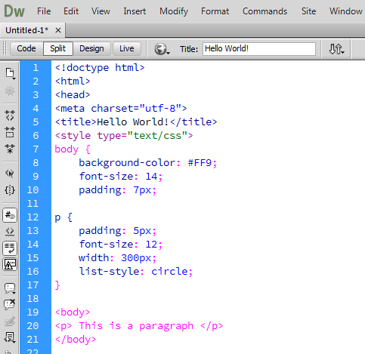

* Which CSS rule is inherited?
* Write down the format of the paragraph:
* Write down the format that will be applied to all the contents: